**Module:**

**Database Systems: Design and Online**

**BIS2212**

**Assignment Title:**

**Coursework 3 –**

**Website and Online Database**

**AUTHORS: Andrea Rizzo & Andrea Montesin**

**STUDENT ID NUMBERS:** **M00433848 & M00433863**

**CENTRE: STC Training Malta /**

**Middlesex University London**

**CLASS: 2nd Year BSc IAD PT 2012 Class**

**DATE HANDED IN: 26th April, 2013**

**LECTURER: Mr. John Debono**

**MODULE LEADER: Dr. Nawaz Khan**

**Table of Contents**

Website Brief Description 8

The Website – *(www.AAAutotrading.com)* 8

Website Working Pages 9

Working Pages Table 9

Home Page – *(Home.aspx)* 10

About Us Page – *(AboutUs.aspx)* 10

New Cars Page – *(NewCars.aspx)* 11

New Cars Page – *(NewCars.aspx) - Back End Code* 11

Fig.1 – New Cars Back End Code 11

Back End - Part 1 -NewCars - Page_Load: 12

Fig.2 – New Cars SearchQuery 12

Fig.3 – New Cars gvVehicle_SelectedIndexChanged 12

Back End - Part 2 -NewCars - gvVehicle_SelectedIndexChanged: 13

Used Cars Page – *(UsedCars.aspx)* 14

Used Cars Page – *(UsedCars.aspx) - Back End Code* 14

Fig.4 – Used Cars Back End Code 14

My Cars Page – *(CustomerCars.aspx)* 15

My Cars Page – *(CustomerCars.aspx) - Back End Code* 15

Part1 - CustomerCars - Initialisation: 15

Part2 - CustomerCars - Page_Load: 15

Fig.5 – VehicleFunction.UserVehicles Function 16

Part3 - CustomerCars - gvVehicle_RowDeleting: 16

Fig.6 – VehicleFunction.VehicleDel Function 17

Part4 - CustomerCars - gvVehicle_SelectedIndexChanged: 17

Fig.7 – CustomerCars Page 18

Contact Us Page – *(ContactUs.aspx)* 19

Search Area – *(CarSearch.aspx)* 19

Search Area – *(CarSearch.aspx) - Back End Code* 19

Fig.8 – SearchBtn_Click Event 20

Part1 - CarsSingleView - Page_Load: 20

Fig.9 – VehicleFunction.SearchQuery() 21

Fig.10 – CarSearch Page 22

Register Page – *(Register.aspx)* 23

Register Page – *(Register.aspx) - Back End Code* 23

Fig.11 – UserValidation.UserVal() 24

Fig.12 – UserNameValidation.UserVal() 25

Fig.13 – UserFunction.RegUser() 26

Fig.14 – Register Page 27

Login Page – *(Login.aspx)* 28

Login Page – *(Login.aspx) - Back End Code* 28

Part1 - Login - Page_Load: 28

Part2 - Login - btnLogin_Click: 29

Fig.15 – btnLogin_Click - Part 1 And Part 2 30

Fig.16 – UserValFields() 31

Part2 - Login - btnLogin_Click - Continued: 31

User Logged Area – *(UserPanel.aspx or AdminPanel.aspx)* 32

Shopping Cart Page – *(Login.aspx or ShoppingCart.aspx)* 33

ShoppingCart Page – *(Login.aspx/ ShoppingCart.aspx) - Back End Code* 33

Part1 - ShoppingCart - page_Load: 33

Fig.17 – ShoppingCartFunction.gvShopCartFill() 34

Fig.18 – ShoppingCart page_Load 35

Part2 - ShoppingCart - gvShopCart_RowDeleting 35

Fig. 19 – gvShopCart_RowDeleting 35

Fig.20 – ShoppingCartFunction.gvShopCartItemDel() 36

Part 3 - ShoppingCart - btnCheckout_Click: 36

This will be the final step for purchasing the vehicle/s, however as already mentioned this event, requires more attention and additional security, due to its importance and functionality. When the user clicks on the checkout button the user will be redirected to the "Login" page and will have his "UserID" encoded as well (in order to be verified on the login page). Fig.21 illustrates the code underneath the " 36

Fig.21 – btnCehckout_Click 37

Fig.22 – Part3 - Login 38

Part4 - ShoppingCart - adding the order and orderline accordingly and marking the vehicle/s as sold: 39

Fig.23 – OrderFunction.PlaceOrder() 39

Fig.24 – OrderFunction.AddOrderLine() 40

Fig.25 – OrderFunction.VehicleSoldStatus() 40

Fig.26 – OrderFunction.EmptyCart() 41

Add Vehicle Page – *(AddVehicle.aspx)* 42

Add Vehicle Page – *(AddVehicle.aspx) - Back End Code* 42

Part1 - AddVehicle - page_Load: 42

Fig.27 – AddVehicle page_Load 42

Part2 - AddVehicle - DropDownProperties(): 43

Fig.28 – DropDownProperties() 43

Part3 - AddVehicle - btnSave_Click - Part 1: 44

Fig.29 – btnSave_Click - Part1 44

Fig.30 – btnSave_Click - Part2 46

Fig.31 – VehicleFunction.AddVehicle() 47

Admin Panel Page – *(AdminPanel.aspx)* 48

Admin Panel Page – *(AdminPanel.aspx) - Back End Code* 48

Part1 - AdminPanel - gvCategories_RowDeleting: 48

Fig.32 – gvCategories_RowDeleting 49

Fig.33 – CategoryFunction.CategoryDel() 49

Part2 - AdminPanel - gvCategories_RowUpdating: 50

Fig.34 – gvCategories_RowUpdating 50

Fig.35 – CategoryFunction.GVUpd() 50

Part3 - AdminPanel - btnSave_Click: 51

Fig.36 – btnSaveCat_Click 51

Fig.37 – CategoryFunction.AddNewCat() 52

Car Description Page – *(CarSingleView.aspx)* 53

Car Description Page – *(CarSingleView.aspx) - Back End Code* 53

Part 1 -CarsSingleView - Page_Load: 53

Fig.38 – CarsSingleView - Part1 - PageLoad 54

Fig.39 – Requesting the Vehicle ID 55

Fig.40 – Verifying if the user is logged in to avail btnAddToCart 55

Fig.41 – Verifying UserID to enable the Delete Button 56

Fig.42 – Verifying UserID to enable the Delete Button 57

Part 2 -CarsSingleView - BindingVehicleData(): 57

Fig.43 – BindingVehicleData() 58

Part 3 -CarsSingleView - AltImgBinding(): 58

Fig.44 – AltBindingVehicleData() 59

Part 4 - CarsSingleView - btnImg_Click: 59

Fig.45 – btnImg_Click 60

Part 5 -CarsSingleView - Deleting a vehicle: 60

Fig.46 – AltBindingVehicleData() 60

Part 6 -CarsSingleView - VehicleDel() 61

Fig.47 – AltBindingVehicleData() 62

Part 7 -CarsSingleView - btnAddCart_Click: 63

Fig.48 – btnAddCart_Click 63

ShoppingCartVehicleVal: 63

Fig.49 – ShoppingCartVehVal() 64

Fig.50 – AddToCart() 65

Checkout Page – *(Checkout.aspx)* 66

User Panel Page – *(UserPanel.aspx)* 67

User Panel Page – *(UserPanel.aspx) - Back End Code* 67

Fig.51 – UserPanel page 67

Part1 - UserPanel - page_Load: 68

Fig.52 – OrderFunction.gvOrderFill() Function 68

Part2 - UserPanel - gvOrder_SelectedIndexChanged: 68

Part3 - UserPanel - btnAddVeh_Click: 68

Website Additional Files and Database 69

Database 69

User Table: 69

Fig.53 – User Table 69

Fig.54– Populated OrderLine Table 70

ShoppingCart Table: 70

Fig.55 – ShoppingCart Table 70

Fig.56 – Populated ShoppingCart Table 71

Order Table: 71

Fig.57 – Order Table 71

Fig.58 – Populated Order Table 71

OrderLine Table: 72

Fig.59 – OrderLine Table 72

Fig.60 – Populated OrderLine Table 72

Category Table: 73

Fig.61 – Category Table Structure 73

Fig.62 – Populated Category Table 73

Vehicle Table: 74

Fig.63 – Vehicle Table Structure 74

Fig.64– Populated Vehicle Table 75

Connection 76

Fig.65– Conn.OpenConn() & Conn.CloseConn() 76

Cascading Style Sheets (CSS) 77

Body CSS: 77

Fig.66– Body CSS 77

Wrapper CSS: 77

Fig.67– Wrapper CSS 77

Top Bar CSS: 78

Fig.68– Top Bar CSS 78

lblSearch / txtbSearch / btnSearch CSS: 78

Fig.69– lblSearch / txtbSearch / btnSearch CSS 78

Top Shop Cart CSS: 79

Fig.70– Top Shop Cart CSS 79

Top Reg Log CSS: 80

Fig.71– Top Reg Log CSS 80

Banner CSS: 81

Fig.72– Banner CSS 81

Menu CSS: 82

Fig.73– Menu CSS 82

Content Area CSS: 83

Fig.74– Content Area CSS 83

Content Home CSS: 84

Fig.75– Content Home CSS 84

Footer Bar CSS: 85

Fig.76– Footer Bar CSS 85

Website Images and Information: 86

Website Images and Information Table 86

Website Screen Shots (Functionality) 87

Fig.77 – Home Page 87

Fig.78 – About Us Page 87

Fig.79 – New Cars Page 88

Fig.80 – Used Cars Page 88

Fig.81 – My Cars Page (Not logged in) 89

Fig.82 – My Cars Page (Logged in) 89

Fig.83 – Contact Us Page 90

Fig.84 – Search Area (search for Chrysler Make) 90

Fig.85 – Search Area (Returned Chrysler Make) 91

Fig.86 – Registering Customer 91

Fig.87 – Registering Customer (Successful) 92

Fig.88 – Login Customer (Username: MC Password: MC1) 92

Fig.89 – Login Customer (Username: MC Successful) 93

Fig.90 – Login Administrator (Username: RA Password: RA1) 93

Fig.91 – Login Administrator (Username: RA Successful) 94

Fig.92 – Users List from Admin’s Panel 94

Fig.93 – Vehicles List from Admin’s Panel 95

Fig.94 – Vehicles List from Admin’s Panel 95

Fig.95 – Add new Vehicle template form from Admin’s / User’s Panel 96

Fig.96 – Car Description Page 97

Fig.97 – Shopping Cart Page (Empty) 98

Fig.98 – Shopping Cart Page (Vehicle added) 98

Fig.99 – Checkout Page (Vehicle Purchase complete) 99

Fig.100 – User’s Panel Page (Past Orders Purchase) 99

Appendix 100

Website and Report in Electronic Version (CD-ROM) 100

# Website Brief Description

## The Website – *(www.AAAutotrading.com)*

The product chosen to create and design the website upon was automotive vehicles in general i.e. to create an online auto trading company which was ultimately named “*A & A Autotrading Limited”.* The website that was created depicts an online version of what a real showroom would look like with the only difference being that the vehicles can be viewed from the commodity of home.

The website was created to show the selection of vehicles which are available from the auto trading company. There are two main sections available and these are divided between “*New Cars”* and *“Used Cars”* (second hand). The “*New Cars”* section contains vehicles owned by the company itself while the *“Used Cars”* type contains vehicles which are also owned by the company but may also contain cars that are owned by registered customers within the company, due to the fact that customers have the opportunity to put up their second hand cars for sale by using the “*User Panel”.*

The auto trading company gives the possibility be used by the registered customers as an intermediary company to advertise their cars under the “*Used Cars*” type and ultimately when the car is sold a percentage of the profit goes towards the auto trading company. Another section is the “*My Cars”* section which allows registered customers once logged in into the website to view any vehicles which they may have uploaded and put for sale within the auto trading company.

The car selection available within the website can be viewed anonymously i.e. it is open to be viewed by non-registered customers by using the “*New Cars”* and *“Used Cars”* sections or try and search a particular vehicle by using the “*Search”* box area. In order for customers to be able to buy vehicles from the website they must first register a username on their behalf and then login with that username. Following this they can select any particular car they wish to buy which will be then placed into their shopping cart.

Customers can then access their shopping cart and proceed with the checkout process to complete the vehicle purchase or logout and return another time as the shopping cart will be stored and can be accessed the next time they login into the website.

# Website Working Pages

The table described below is a list of the working pages within the “*A & A Autotrading Limited” website*, all of which have been fully implemented apart from one which was still under construction.

|  |  |  |  |
| --- | --- | --- | --- |
| **Page** | **Status** | **Links to** | **Links from** |
| Home | Implemented | Home / General Info | Entire website |
| About Us | Implemented | About Us Info | Entire website |
| New Cars | Implemented | New Cars / Add to Cart | Entire website |
| Used Cars | Implemented | Used Cars / Add to Cart | Entire website |
| My Cars | Implemented | My Cars / Add Vehicles | Entire website |
| Contact Us | Under Construction * | Contact Us / Send E-mail | Entire website |
| Search Area | Implemented | Car Search | Entire website |
| Register | Implemented | Login | Entire website |
| Login | Implemented | User ‘s or Admin’s Panels | Entire website |
| User Logged Area | Implemented | Login / User ‘s  or Admin’s Panels | Entire website |
| Shopping Cart | Implemented | Login / Checkout / Buy Vehicle | Entire website |
| Add Vehicle | Implemented | Add Vehicle | User and Admin Panels |
| Admin Panel | Implemented | Users / Vehicles / Categories  and Add Vehicles | Login / User Logged (Area) |
| Car Description | Implemented | Vehicle Description Add to Cart  Delete Vehicle | New Cars / Used Cars /  My Cars / User’s Panel /  Admin’s Panel |
| Checkout | Implemented | Checkout / Shopping | Shopping Cart |
| User Panel | Implemented | Add / Delete Vehicles | Login and User Logged |

* The *Contact Us* is the only page which wasn’t fully completed as it was deemed less important and does not affect the global functionality of the website and was not an assignment requirement.

### Working Pages Table

## Home Page – *(Home.aspx)*

This page is the start page of the website and contains a brief but detailed description promoting the types and categories of vehicles on offer by the company “*A & A Autotrading Limited”* and also explains some important measures implemented by it when it comes to selected and approving second hand vehicles.

The “*Home”* page can be accessed from anywhere whilst browsing within the website as it is featured in the main menu which is present throughout all the pages in the website, making the customer experience much easier and pleasant to find his way around.

## About Us Page – *(AboutUs.aspx)*

This page of the website contains a brief description on the “*A & A Autotrading Limited”* company, highlighting some information about it like when the company was formed, the owners of the company and the objectives the company is trying to achieve.

The “*About Us”* page can be accessed from anywhere whilst browsing within the website as it is featured in the main menu which is present throughout all the pages in the website, making the customer experience much easier and pleasant to find his way around.

## New Cars Page – *(NewCars.aspx)*

This page of the website contains the selection of new vehicles which are available at “*A & A Autotrading Limited”.* When the page loads a list of all the new vehicles is populated from which customers can select their desired one and be then directed to a more detailed description and additional photos of the same vehicle via a new page. This page (“*Car Description*”Page) will be discussed later on.

The “*New Cars”* page can be accessed from anywhere whilst browsing within the website as it is featured in the main menu which is present throughout all the pages in the website, making the customer experience much easier and pleasant to find his way around.

## New Cars Page – *(NewCars.aspx) - Back End Code*

Below in Fig.1 one can find illustrated the back end design including the populated gridview for the "New Cars" page.

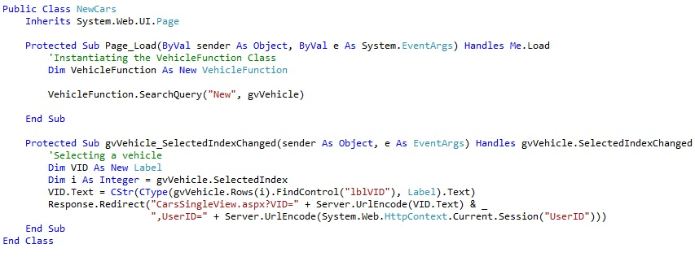

### Fig.1 – New Cars Back End Code

### Back End - Part 1 -NewCars - Page_Load:

Right in the **Page_load** for the "NewCars" page, one can find an instance of the "**VehicleFunction**" class. This instance will be used to access the "**SearchQuery**" function (shown in Fig.3) found in the same "**VehicleFunction**" class.

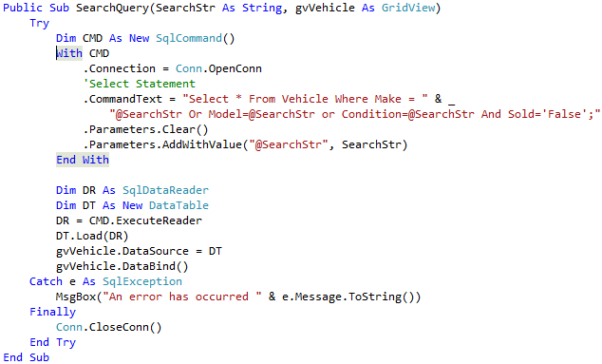

### Fig.2 – New Cars SearchQuery

The "SearchQuery" function will pass "New" through the parameter "@SearchStr" to the **Select** statement. This function will finally select all the vehicles (from the Vehicle table) where their condition is new, and bind the results to the gridview (gvVehicle).

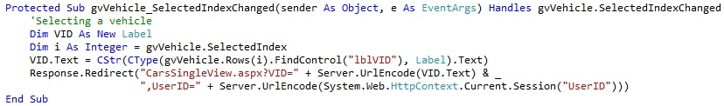

### Fig.3 – New Cars gvVehicle_SelectedIndexChanged

### Back End - Part 2 -NewCars - gvVehicle_SelectedIndexChanged:

The second part of the NewCars page being "**gvVehicle_SelectedIndexChanged**" (shown in Fig.3 (above)) will be used to select a vehicle and view its full description. Therefore when the user clicks on the (auto-generated) Select link button from the gridview, our website will find control on the gridview (bound) column name "**lblVID**" in order to retrieve the vehicle ID and pass it as an "encoded string" to the "**CarsSingleView**" page. Apart from the Vehicle ID the User ID is also passed to the "**CarsSingleView**" page, in order to maintain an extra user verification tracks, apart from the session.

## Used Cars Page – *(UsedCars.aspx)*

This page of the website contains the selection of used vehicles which are available at “*A & A Autotrading Limited”.* When the page loads a list of all the used vehicles is populated from which customers can select their desired one and be then directed to a more detailed description and additional photos of the same vehicle via a new page. This page (“*Car Description*”Page) will be discussed later on.

The “*Used Cars”* page can be accessed from anywhere whilst browsing within the website as it is featured in the main menu which is present throughout all the pages in the website, making the customer experience much easier and pleasant to find his way around.

## Used Cars Page – *(UsedCars.aspx) - Back End Code*

The "UsedCars" page illustrated in Fig.4 uses the same logic as the "NewCars" page. The only difference between both pages is that the "UsedCars" will select all the vehicles that its condition is "Second Hand", apart from that everything (the back end code) is identical.

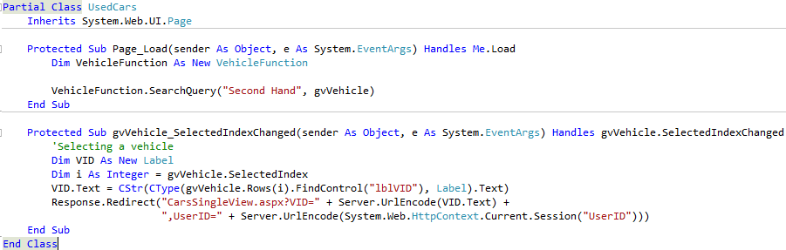

### Fig.4 – Used Cars Back End Code

## My Cars Page – *(CustomerCars.aspx)*

This page of the website contains the vehicle/s which any registered customers may have put up for sale within “*A & A Autotrading Limited”.* The vehicle/s can only be seen by their respective said registered customer and only when he is logged in with his username. However these vehicles are also available to the other registered customers under the “*Used Cars”* page for their viewing but no reference will be made to whom particular customer they belong. When the “*My Cars”* page loads the vehicle/s list is populated for the particular owning customer and can select whether to delete it from “*A & A Autotrading Limited”* or be directed to a more detailed description and additional photos of the same vehicle via a new page. This page (“*Car Description*”Page) will be discussed later on.

The “*My Cars”* page can be accessed from anywhere whilst browsing within the website as it is featured in the main menu which is present throughout all the pages in the website, making the customer experience much easier and pleasant to find his way around.

## My Cars Page – *(CustomerCars.aspx) - Back End Code*

### Part1 - CustomerCars - Initialisation:

First we will start by instantiating both "VehicleFunction" and "VehicleData", these instance may be called globally throughout the page. "VehicleFunction" class will be used to get certain functions we will require for this page, and the "VehicleData" will be used as the "Getter" and "Setter" class for the Vehicle table.

### Part2 - CustomerCars - Page_Load:

On page load we will validate the following:

**Validation Points on Page_Load:**

* Whether the user is logged in:
  + If the user is logged then he the solution will resume the execution, otherwise will halt the user and redirect to "Login.aspx" page.
* If the user listed any vehicles:
  + If the user is logged in, then we will call the function "UserVehicles" from the "VehicleFunction" class (illustrated below in Fig.5), this function will be used to select all the vehicles that were created by the current user and populate the gridView with the results (if any).

Then we will validate whether he has listed any vehicles or not, if he hasn't listed any vehicles yet, our website will notify the user. However if the user added any vehicles they will be displayed in the gridview "gvVehicle" included in the CustomersCars page.

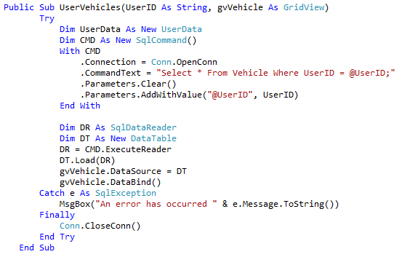

Fig.5 – VehicleFunction.UserVehicles Function

### Part3 - CustomerCars - gvVehicle_RowDeleting:

The " gvVehicle_RowDeleting" event will be fired when the user clicks the "Delete" link in the gridview.

Upon firing of the event the solution will prompt the user whether he really intends to delete the selected vehicle. If the answer is yes (6), then the solution will get the selected vehicle ID "V_ID" from the gridview, and check whether the vehicle to be deleted is sold or not. However, if the vehicle will be marked as sold on the Vehicle Table then the user will not to be able to delete it, for (our) record purposes. On the other hand if the vehicle is not sold, then the solution will continue deleting the vehicle and refreshing the "gvVehicle" gridview. The function that will allow the user/s to delete a vehicle is the "VehicleDel" function which may be accessed from the "VehicleFunction" class.

The "VehicleDel" function includes a delete statement, which consequently will delete the selected vehicle. This function is shown below in Fig.6.

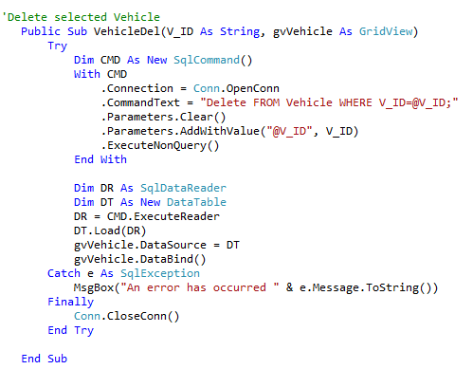

Fig.6 – VehicleFunction.VehicleDel Function

### Part4 - CustomerCars - gvVehicle_SelectedIndexChanged:

Finally this event will fire upon the user's "Select" link button (embedded in the gvVehicle), and will continue to load the selected vehicle in the "CarsSingleView.aspx" page. The "CarsSingleView " page was already explained previously in the "CarsSingleView" section.

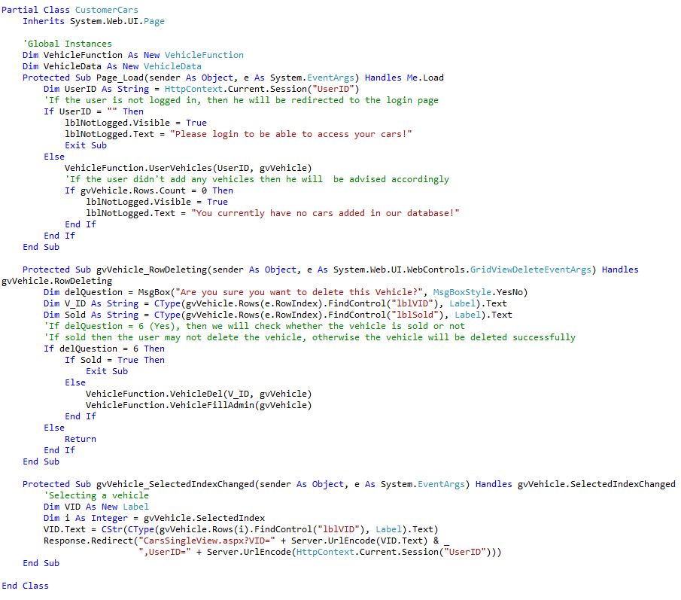

Fig.7 – CustomerCars Page

## Contact Us Page – *(ContactUs.aspx)*

This page of the website has been partially implemented but visually only (front end side) and it is still under construction (back end side) and could not be completed on time. It was deemed of less importance and as it does not affect the global functionality of the website and was not an assignment requirement it was left in this state.

## Search Area – *(CarSearch.aspx)*

This area of the website contains a text area were customers can search for any Model or Make of Vehicle they wish and check if they are available at “*A & A Autotrading Limited”* irrespective of their condition*.* When the customer hits the “*GO*” button if such vehicles are available a list of them is populated from which customers can select their desired one and be then directed to a more detailed description and additional photos of the same vehicle via a new page. This page (“*Car Description*”Page) will be discussed later on. If no such vehicles are available the customer will be notified accordingly

The “*Search”* area can be accessed from anywhere using this text area  whilst browsing within the website as it is featured and present throughout all the pages in the website, making the customer experience much easier and pleasant to find his way around.

## Search Area – *(CarSearch.aspx) - Back End Code*

The back end code behind the search bar is located in the MasterPage, in order to be accessed globally throughout the entire website.

Upon pressing the search button, our solution will encode the search text (inputted in txtbSearch) and will navigate to the "CarSearch" page.

The code behind the search button click "btnSearch_Click" is as follows (Fig.8).



Fig.8 – SearchBtn_Click Event

### Part1 - CarsSingleView - Page_Load:

Initially on page_load we will be requesting the "SearchString" previously passed from the search bar. Upon requesting the "SearchStr" we will be validating for the following eventualities:

**Validation Points on Page_Load:**

1. Whether the "SearchStr" is empty, thus the user just clicked on the search button without entering any text.
2. Whether the search term the user used is found in our database.

On both validation points the user will be advised if the condition of the above points result to true.

However if point 1 results to "False" then we will run the "VehicleFunction.SearchQuery" function.

This function (shown below in Fig.9), will select the details from the Vehicle table (through a select statement), and will search on either make, model or condition. Finally the results of the "SearchQuery" will be populated on the "gvVehicle" gridView. Otherwise if no data is found, then validation point 2 will result to "True".

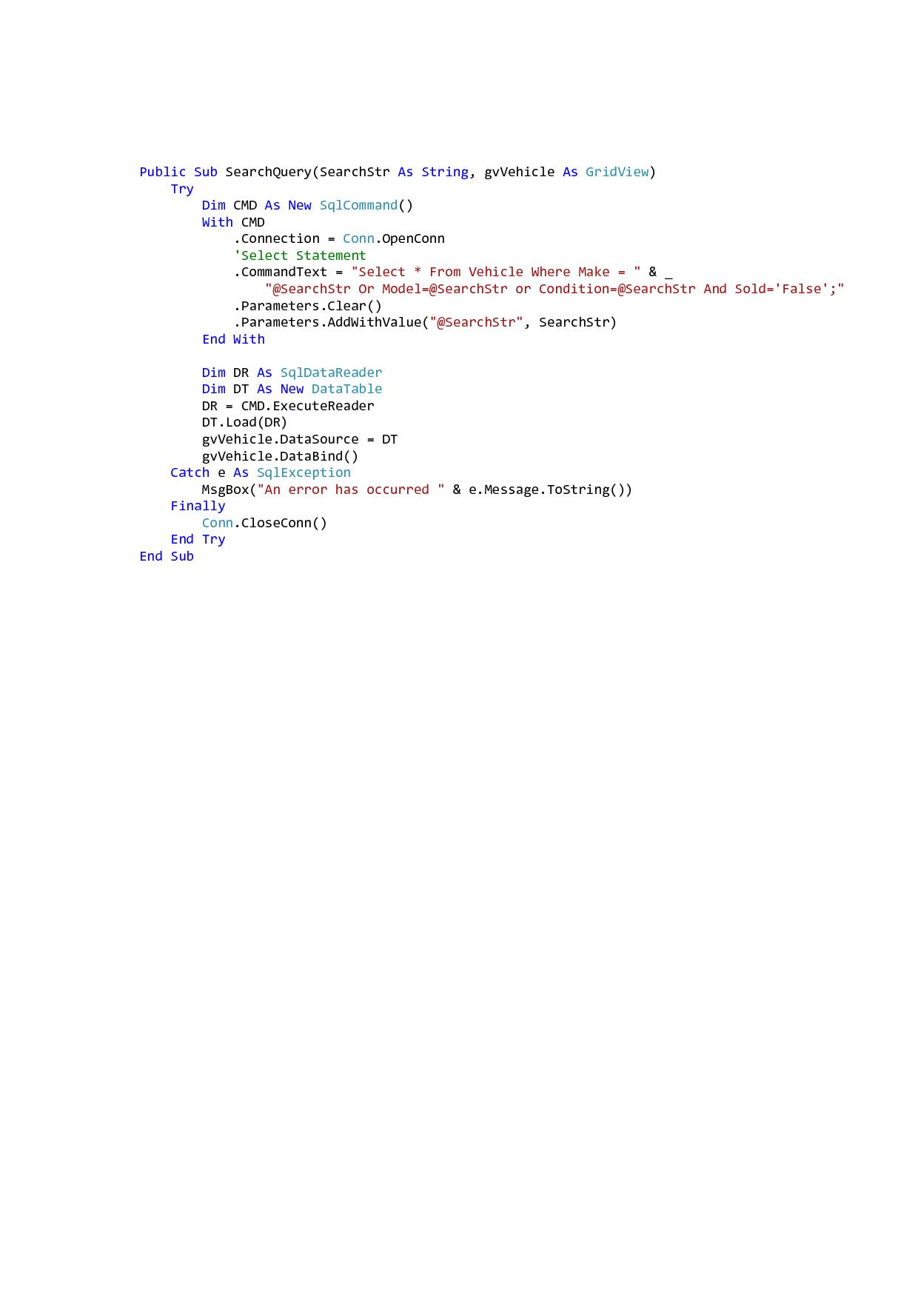

Fig.9 – VehicleFunction.SearchQuery()

The gvVehicle_SelectedIndexChanged is identical as in the "NewCars, UsedCars, MyCars" sections. Below one can find the full code of the "CarSearch" page.

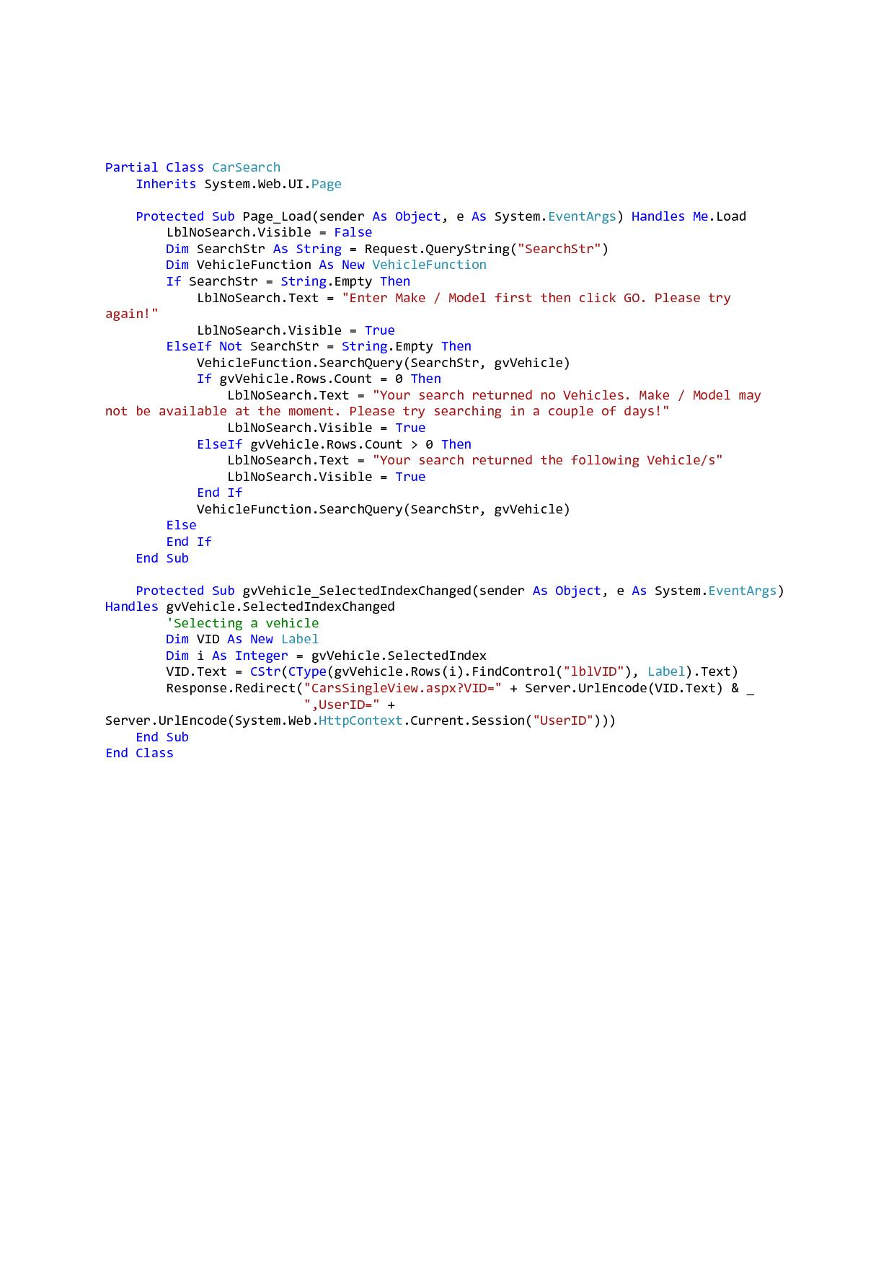

Fig.10 – CarSearch Page

## Register Page – *(Register.aspx)*

This page of the website contains text areas where new customers can register their username with “*A & A Autotrading Limited”* so they could benefit from the opportunity to put up their vehicles for sale and also be able to buy vehicles from the website*.* When the customer fills in all the required fields and hits the “*Register*” button a confirmation that his username was successfully created comes up and advises the customer. The newly registered customer is then taken onto a new page to insert his username credentials and start using the auto trading website to its full potential. This page (“*Login*”Page) will be discussed next.

The “*Register”* page can be accessed from anywhere whilst browsing within the website as it is featured and present throughout all the pages in the website, making the customer experience much easier and pleasant to find his way around.

## Register Page – *(Register.aspx) - Back End Code*

Below we are including the validation points upon pressing the register button (regBtn).

**Validation Points on regBtn_Click:**

1. Our solution will validate the below mentioned textboxes if left empty:
   1. Blank name (NameTxt)
   2. Blank surname (SurnameTxt)
   3. Blank UserName (UserNameTxt)
   4. Password (PWDtxt)
2. Another validation point will check whether both passwords inputted by the user in the password textboxes (PWDtxt & PWDMatchtxt) match. If the passwords do not match the program will warn the user and stop execution, on the contrary if the passwords match, the solution will continue.
3. The next validation point will verify, whether the combination of username and password inputted by the user exists in our "User" table and whether the username (only) exists on the same table. This will be done as follows:
   1. The "UserValidation" class will be instantiated, following this the UserVal() will verify if username and password exists in our database, and UserNameVal() will verify if the username(only) exists in the User table. Both functions are illustrated below in Fig.11 and Fig.12 respectively.

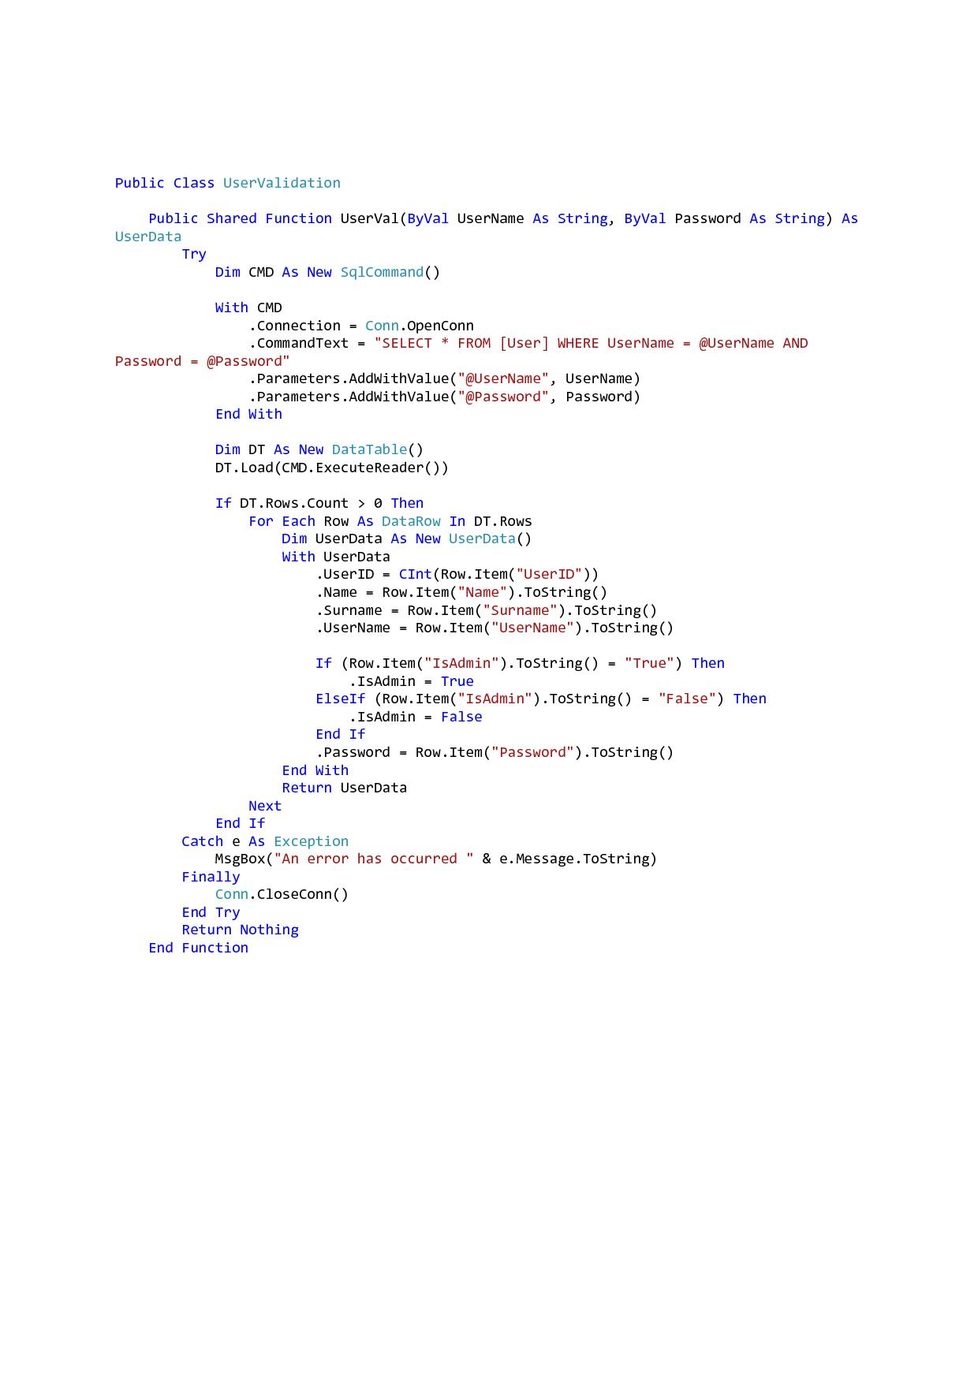

Fig.11 – UserValidation.UserVal()

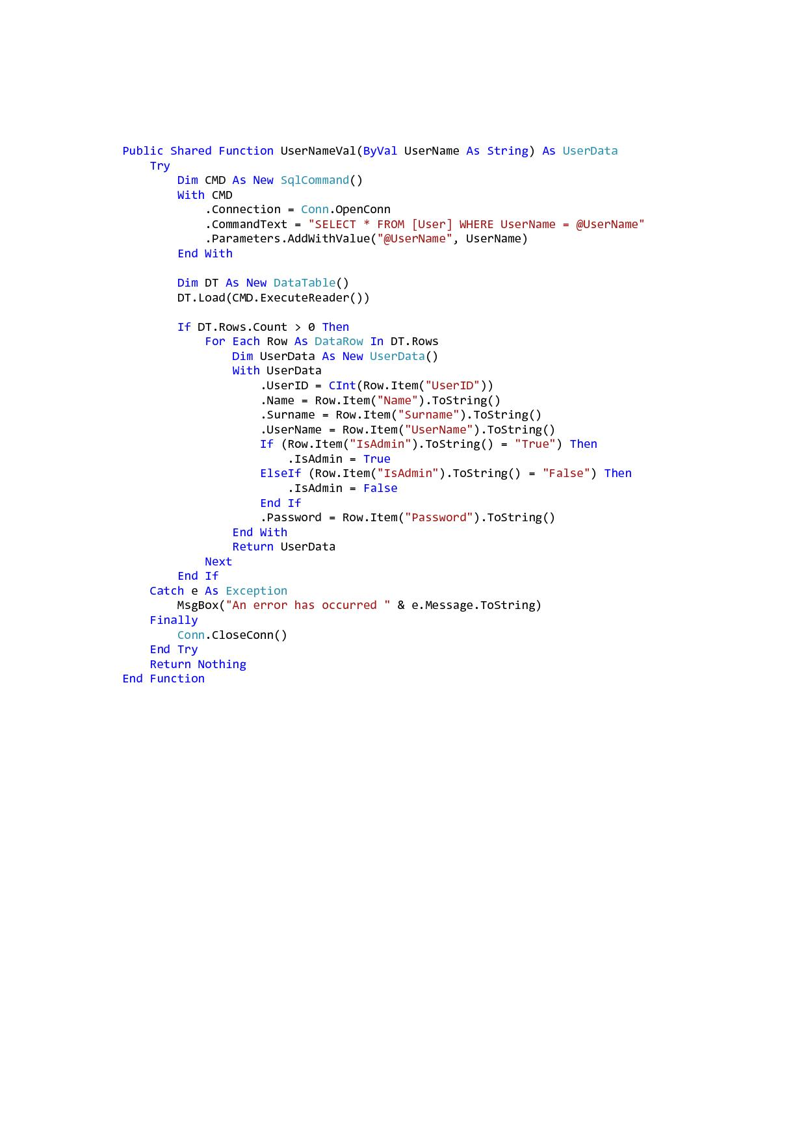

Fig.12 – UserNameValidation.UserVal()

If the above mentioned validation points do not execute, therefore the data inputted is correct, then the program will continue to add the user to the "User" table accordingly. This will be done by calling the "RegUser()" function from the (instantiated) class "UserFunction".

The "RegUser()" function will retrieve all the data from the textboxes "Register" page and will insert this data into the "User" table. This function is illustrated in Fig.13, and can be accessed from the "UserFunction" class. Whilst Fig.14 illustrates the back end code behind the "Register" page.

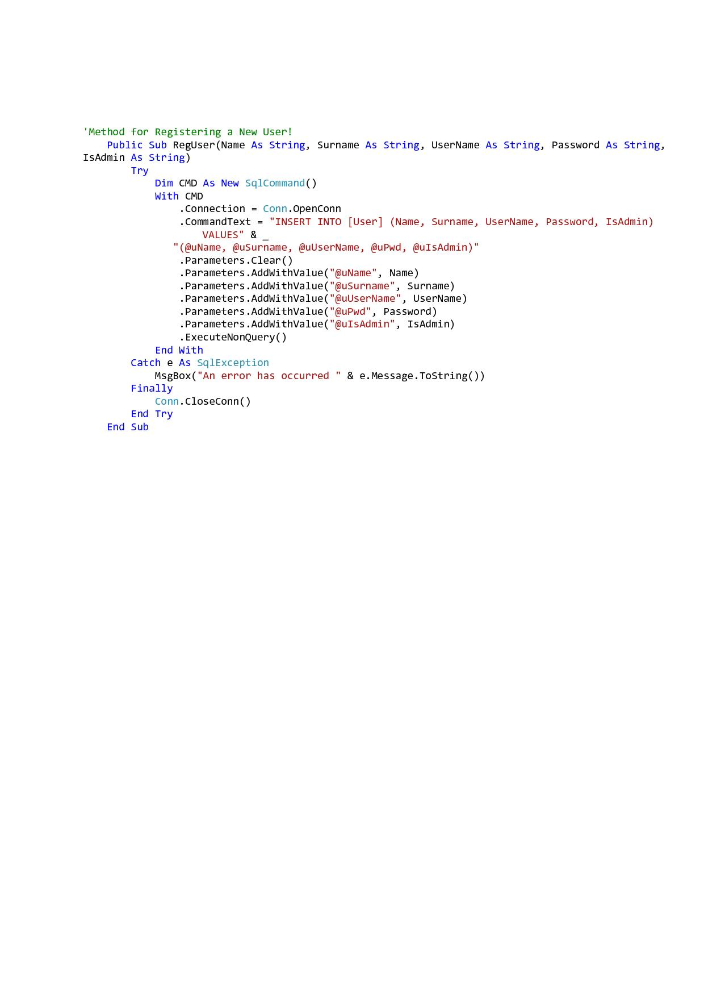

Fig.13 – UserFunction.RegUser()

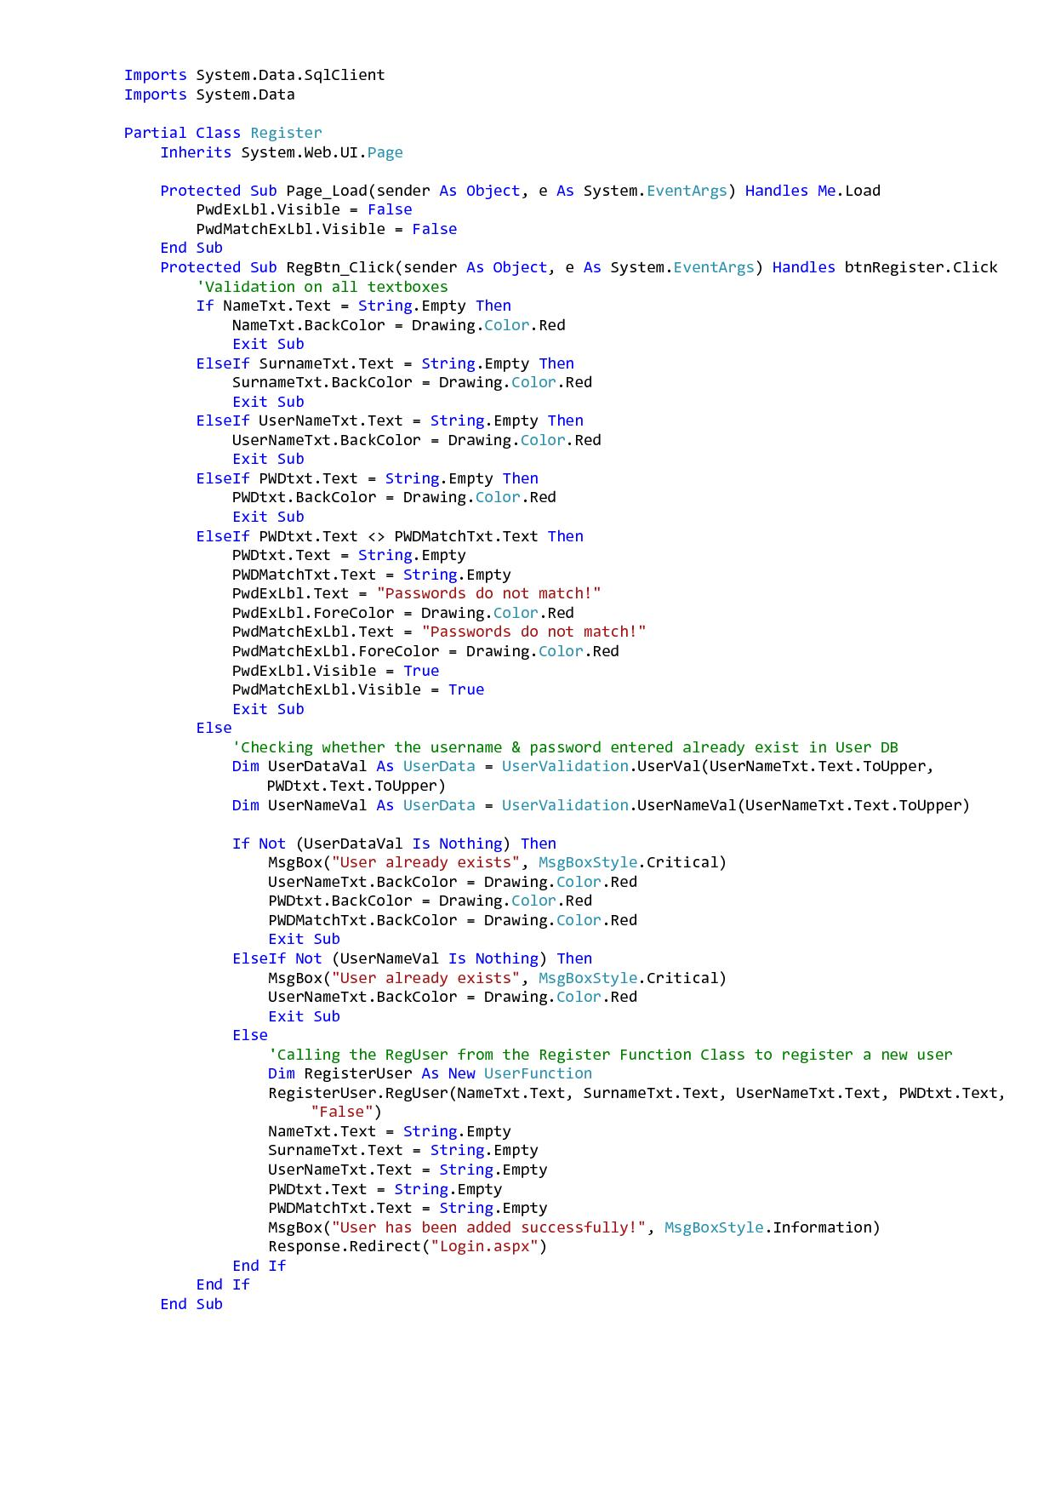

Fig.14 – Register Page

## Login Page – *(Login.aspx)*

This page of the website contains text areas where an already registered customer or administrator can login using their username and password onto the “*A & A Autotrading Limited”* website*.* When the customer fills in all the required fields and hits the “*Login*” button he is taken onto a new page or may be called also a panel, it is possible for him to start adding up his vehicle/s for sale within the company. This page / panel (“*User’s*”Panel) will be discussed later on. In case he doesn’t have or wants to add any vehicles he can continue browsing the website in search for his desired vehicle, with the difference now being that if he wants he can use the “*Add to cart*” button when in the “*Car Description*”Page and proceed to his assigned shopping cart to purchase the car.

When the administrator fills in all the required fields and hits the “*Login*” button he is taken onto a new page or may be called also a panel, it is possible for him to add or delete vehicles for sale and also vehicle categories types of within the company. This page / panel (“*Admin’s*”Panel) will be discussed later on. In case he doesn’t want to add / delete any vehicles / categories he can continue browsing the website.

The “*Login”* page can be accessed from anywhere whilst browsing within the website as it is featured and present throughout all the pages in the website, making the customer experience much easier and pleasant to find his way around.

## Login Page – *(Login.aspx) - Back End Code*

The Login page will be the actual login page, this page contains various functions that will lead to the Admin Panel / User Panel, depending on whether the logged in user is an administrator or not, and will also update UserLogged link button (already mentioned above).

### Part1 - Login - Page_Load:

The Page_Load in our case doesn't contain any notable code, since it contains only some properties for certain labels, these properties may including disabling visibility to selected labels.

### Part2 - Login - btnLogin_Click:

When the user click on the login button "btn_Login" , the clickable event will fire accordingly. We will start this event by instantiating the "UserData" class. Secondly to make sure that there will be no conflict between sessions, we added the option to remove all sessions upon button click.

If the UserID string is empty then we will validate the username and password textboxes (txtUserName and txtPWD) through the "UserValFields()" function. The "UserID" string is a string that will be passed from the "ShoppingCart" page, which will be documented accordingly later on.

**UserValFields():**

This function will provide the necessary validation on the username and password textboxes (txtUserName and txtPWD). Therefore the validation points will validate the following:

**Validation Points on btnLogin_Click:**

1. Will validate on blank username and password textboxes.
2. Will validate whether the username and password entered exist in the "User" table.
3. If the user didn't pass the validation points included in the UserValFields(), then the program will refrain from redirecting the user to either the "UserPanel" or "AdminPanel".

If the above mentioned validation points result in "False" then our solution will continue by adding the sessions for the "UserID", "UserName" and "IsAdmin".

The event "btnLogin_Click" is illustrated in Fig.15, whilst "UserValFields()" function is shown in Fig.16 .

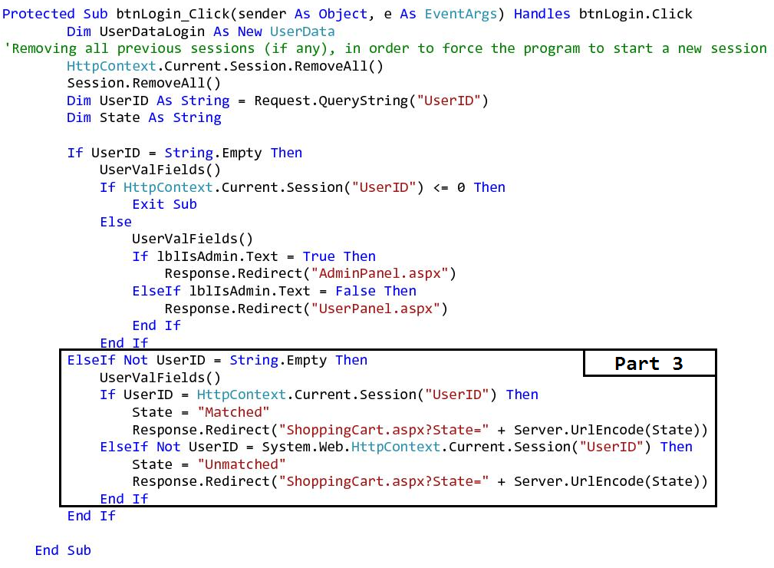

Fig.15 – btnLogin_Click - Part 1 And Part 2

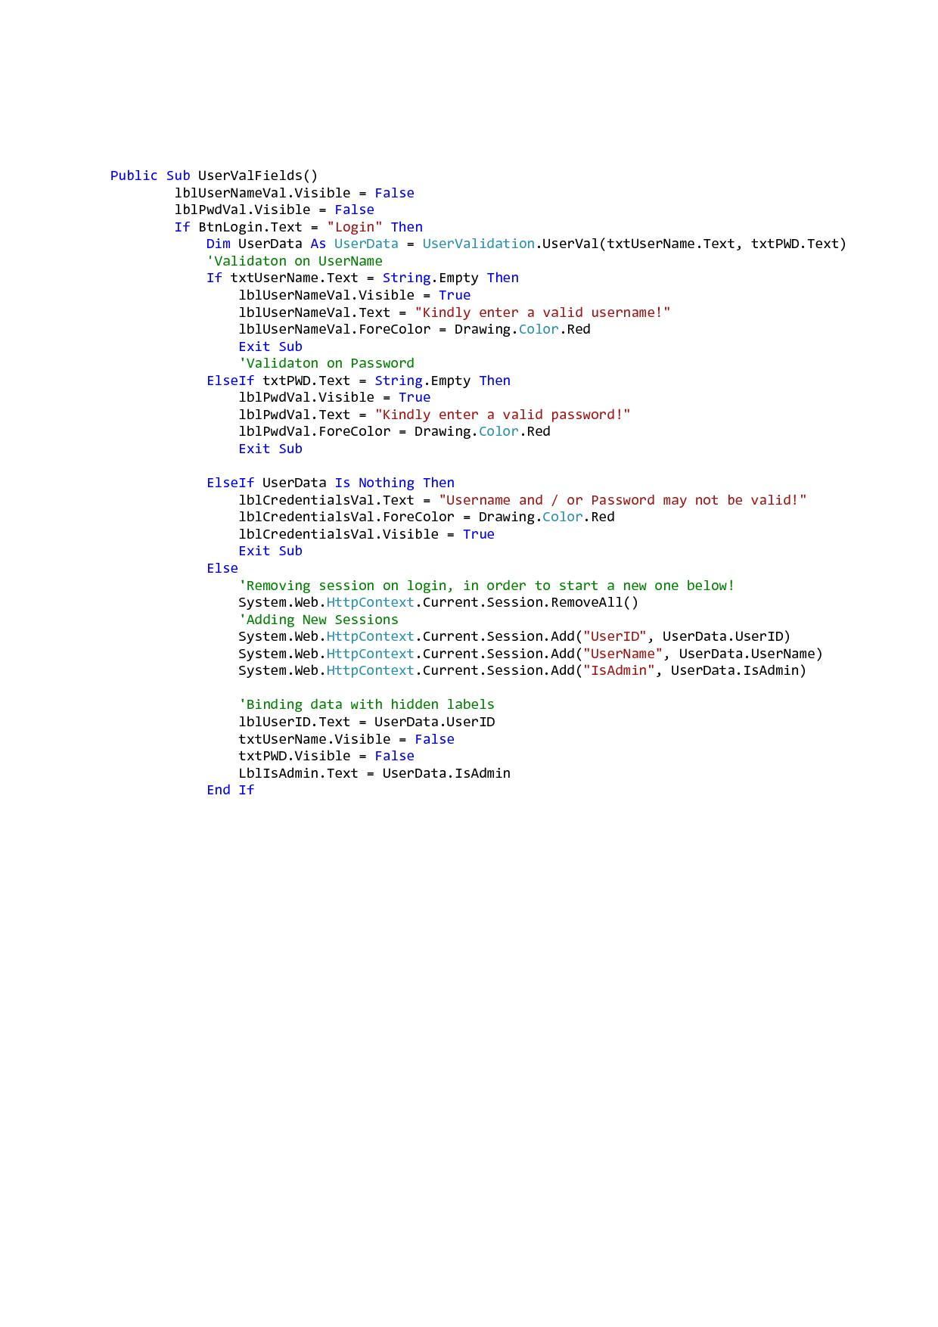

Fig.16 – UserValFields()

### Part2 - Login - btnLogin_Click - Continued:

If the user passes all the validations in the "UserValFields()" then if the user will be redirected to either the "UserPanel" or to the "AdminPanel" pages, obviously this depend on whether the user is an admin or not. (Both the "UserPanel" and "AdminPanel" will be documented further below.

**N.B: Part 3 will be documented later on, in the ShoppingCart section.**

## User Logged Area – *(UserPanel.aspx or AdminPanel.aspx)*

This area of the website consists of an area where a logged in customer / administrator can access their respective control panels i.e. “*User’s*” or “*Admin’s*” Panel*.* This user logged area can be used when a customer or administrator is browsing around the website but wants to go back to their panels. These pages / panels (“*User’s*” or “*Admin’s*” Panel) will be discussed later on.

The “*User Logged”* area can be accessed from anywhere using the “*KH*” logo  in this case (attributed according to the username of customer or administrator) whilst browsing within the website as it is featured and present throughout all the pages in the website, making the customer and administrator experience much easier and pleasant to find his way around.

## Shopping Cart Page – *(Login.aspx or ShoppingCart.aspx)*

This page of the website contains any vehicle/s which may be added to the shopping cart by a logged in customer from any viewed vehicle they may have wanted by using the “*Add to cart*” button from the said viewed vehicle from the “*Car Description*”Page. This customer here can choose to either remove the vehicle from his shopping cart if he doesn’t want it or continue with the checkout process so as to be able to purchase it. If he chooses to checkout by pressing the “*Checkout”* button he will be directed to the “*Login*” page again to carry out a re-Login verification procedure to verify he is the matching customer of the logged in username and when he presses the “*Checkout”* button again he will be directed to a new page. This page (“*Checkout*” Page) will be discussed later on.

The “*Shopping Cart”* page can be accessed from anywhere using the “*Shopping Cart”* logo  whilst browsing within the website as it is featured and present throughout all the pages in the website, making the customer experience much easier and pleasant to find his way around.

## ShoppingCart Page – *(Login.aspx/ ShoppingCart.aspx) - Back End Code*

The shopping cart will be used by the user to add a vehicle (he intends to buy) to it. The shopping cart has certain features that make it more secure than other pages. Below we will be adding a full description of the "ShoppingCart" page.

### Part1 - ShoppingCart - page_Load:

First we will start by instantiating the "ShoppingCartFunction" and the "OrderFunction" then we will be adding a decimal variable "decPrice" and a string variable "CredentialMatch". Both instances and variables will be used globally, thus throughout the whole page.

The "CredentialMatch" string and "State" string will be used in conjunction with the "btnCheckout".

On page_Load our solution will be checking if the user has any items in his shopping cart, this will be done through the "gvShopCartFill()" function (shown in Fig.17) and may be accessed from the "ShoppingCartFunction" class.

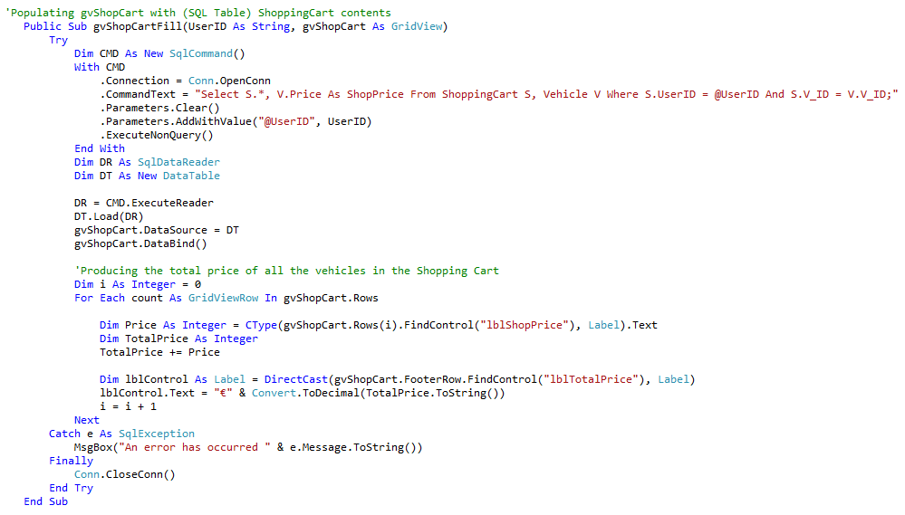

### Fig.17 – ShoppingCartFunction.gvShopCartFill()

If the shopping cart of the current user does not contain any vehicles then the user will be prompted accordingly.

Fig.18 illustrates the "ShoppingCart's page_load".

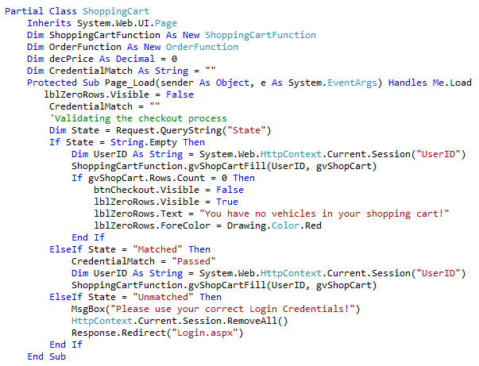

### Fig.18 – ShoppingCart page_Load

Part2 - ShoppingCart - gvShopCart_RowDeleting:

This code will be used to select the shopping cart item and delete if from the cart accordingly. The "gvShopCart_RowDeleting" event is shown in Fig.19.

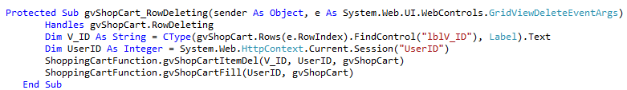

### Fig. 19 – gvShopCart_RowDeleting

This event will fire upon the user pressing the "Delete" link button embedded in grid view, this event will access the "gvShopCartItemDel" available in the "ShoppingCartFunction" class, in order to get and delete the selected vehicle. The "gvShopCartItemDel" is depicted in Fig.20.

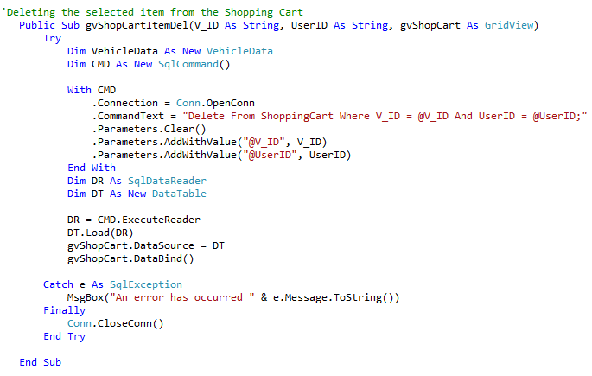

### Fig.20 – ShoppingCartFunction.gvShopCartItemDel()

Part 3 - ShoppingCart - btnCheckout_Click:

This will be the final step for purchasing the vehicle/s, however as already mentioned this event, requires more attention and additional security, due to its importance and functionality. When the user clicks on the checkout button the user will be redirected to the "Login" page and will have his "UserID" encoded as well (in order to be verified on the login page). Fig.21 illustrates the code underneath the "btnCheckout_Click".

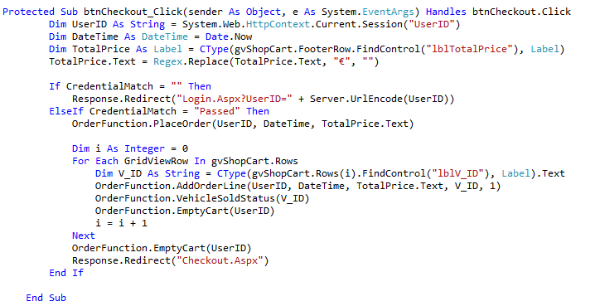

### Fig.21 – btnCehckout_Click

Now we will describe the part 3 of the login process (shown in Fig.22):

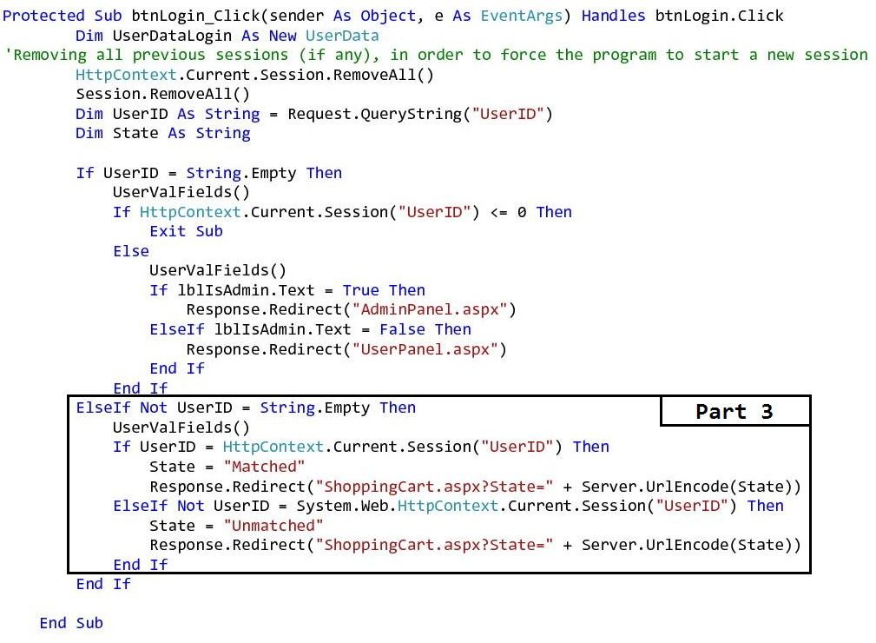

### Fig.22 – Part3 - Login

After the user has been redirected to the login page upon checkout button, the UserID will be decoded upon the login "page_Load". the user will be prompted to re-log in the website in order to conduct a two-step login process. The decoded UserID will be then matched with the current login session, if matched then we will redirect the user to the checkout page and this time we will encode the "State = Matched" string. When the user will be redirected to the shopping cart page if the State is matched then the user may click on the checkout button once more so that he may finalise his purchase. otherwise the user login does not match with the UserID, State will be set as "Unmatched" and will be redirected to the login page again. If the state is "Unmatched" then it means that the user who added the vehicle/s to the shopping and the current logged in user, do not have the same login credential, therefore the order cannot be made.

Part4 - ShoppingCart - adding the order and orderline accordingly and marking the vehicle/s as sold:

When the user checks out and completes the purchase, our solution will create an order through the "PlaceOrder()" function, shown in Fig.23

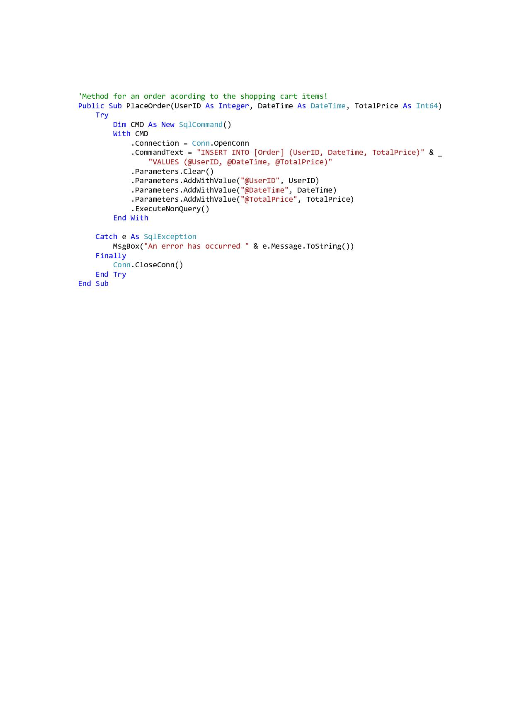

### Fig.23 – OrderFunction.PlaceOrder()

Then the appropriate orderlines for the current order will be created, through the "AddOrderLine()" function, shown in Fig.24.

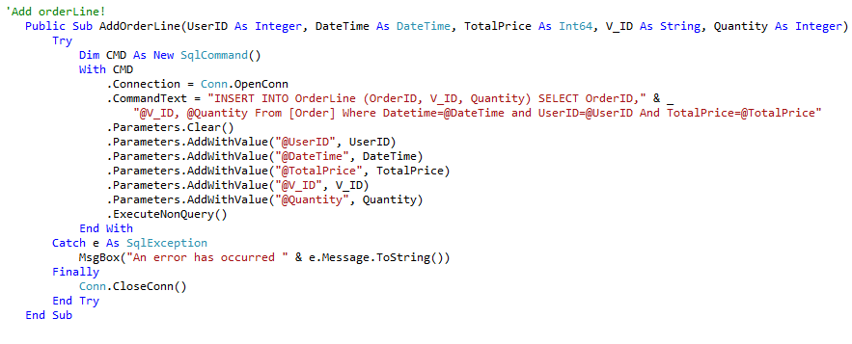

### Fig.24 – OrderFunction.AddOrderLine()

After creating the orderline, then the next step is to mark the vehicle as sold through the "VehicleSoldStatus()" function, and to empty the cart through the "EmptyCart()" function. The vehicle will be marked as sold, since our product is not like many others, therefore no two identical vehicles that have the same identical vehicle ID may exist.

These functions are both shown in Fig.25 and Fig.26 respectively.

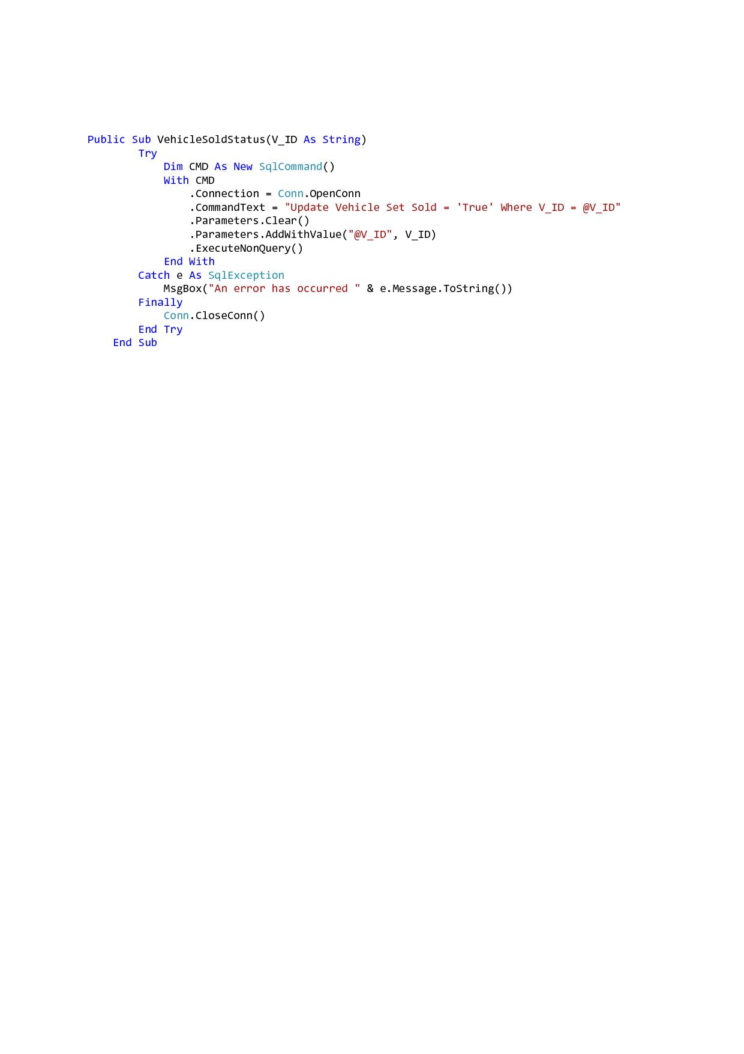

### Fig.25 – OrderFunction.VehicleSoldStatus()

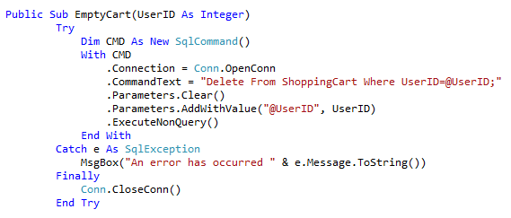

### Fig.26 – OrderFunction.EmptyCart()

## Add Vehicle Page – *(AddVehicle.aspx)*

This page of the website contains a template form where a logged in customer or administrator can access it from their respective panels i.e. “*User’s*” or “*Admin’s*” Panel. The template form contains text areas that need to be filled in as accurately as possible so as to have correct data regarding the vehicle to be added. In addition to this the customer or administrator needs to add also images of the vehicle. When all information is complete all that remains is to hit the “*Save Vehicle*” button and the vehicle is added to the existing “*Used Cars*”.

The “*Add Vehicle”* page can be accessed from the “*User’s Panel*” or “*Admin’s Panel*” respectively whilst the customer or the administrator is logged in onto the website, making the customer and administrator experience much easier and pleasant to find his way around.

## Add Vehicle Page – *(AddVehicle.aspx) - Back End Code*

Initially, this option was intended only for administrators, however we decided to add this option as well for the user as an extra feature. This extra feature will enable (normal) users to add their own vehicles as well.

### Part1 - AddVehicle - page_Load:

On page_Load (Fig.27) we will call the "DropDownProperties()" function in order to populate the dropdown lists included on the "AddVehicle" page.

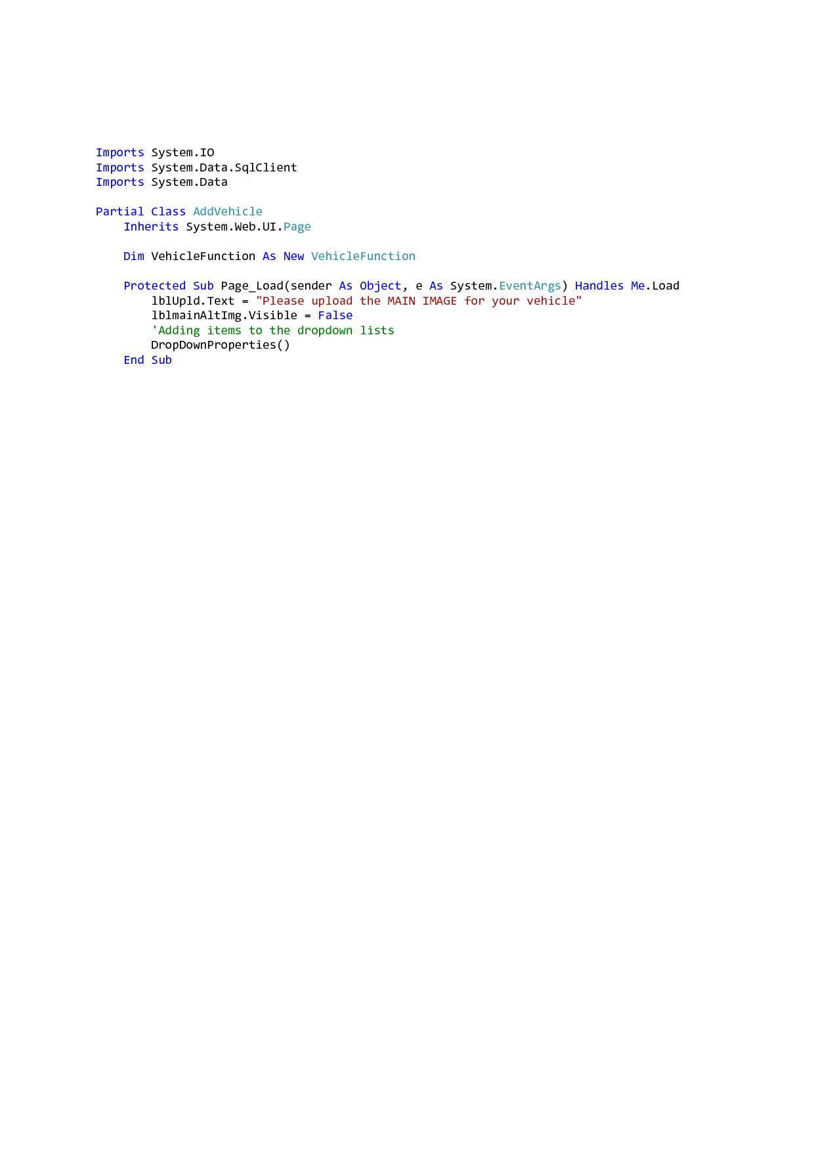

Fig.27 – AddVehicle page_Load

### Part2 - AddVehicle - DropDownProperties():

This function (Fig.28) will be used to populate the dropdown lists with the correct data, accordingly.

The "ddlYr" which will represent the vehicle's year of manufacture, will be populated through a "Do, Until" iteration, with years starting from 1950, up to the current year. All the other drop down lists available will be each populated with the correct data.

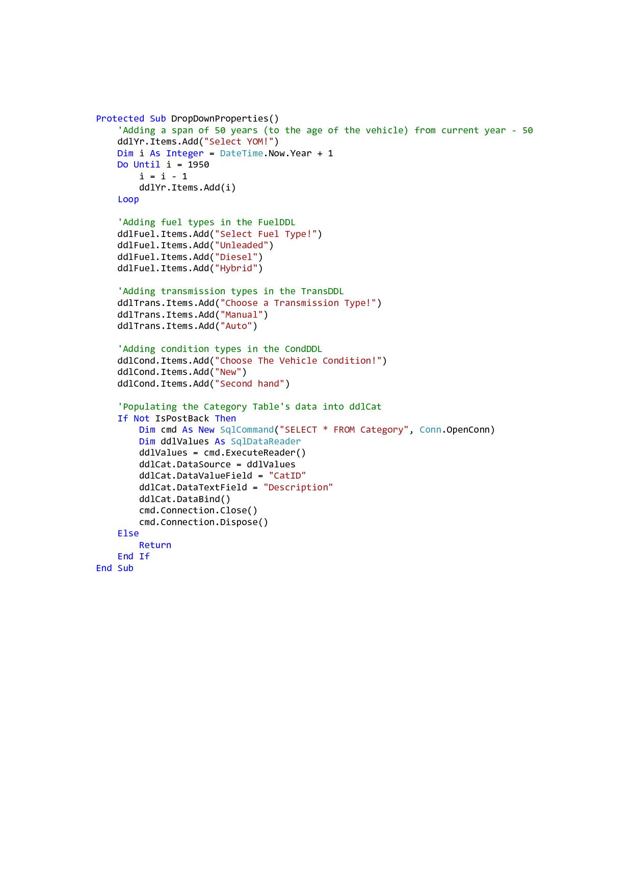

### Fig.28 – DropDownProperties()

### Part3 - AddVehicle - btnSave_Click - Part 1:

In the first part of this function our solution will retrieve the text entered in the vehicle property textboxes. Though we want to keep our "Vehicle" table as clean as possible, we thought that this option  would help us to keep the data standardised. The globalization option will be used to convert the text fetched from the text boxes to title case.

The second feature in the button click event will determine the images which do not have an empty URL, then these images will be concatenated in a comma delimited format. This format will help us to save all the alternate images as one whole string in the "AlternateImgs" column in the "Vehicle" table. In order to save the images in a clean format, the folder name will be removed from the image's URL prior saving them.

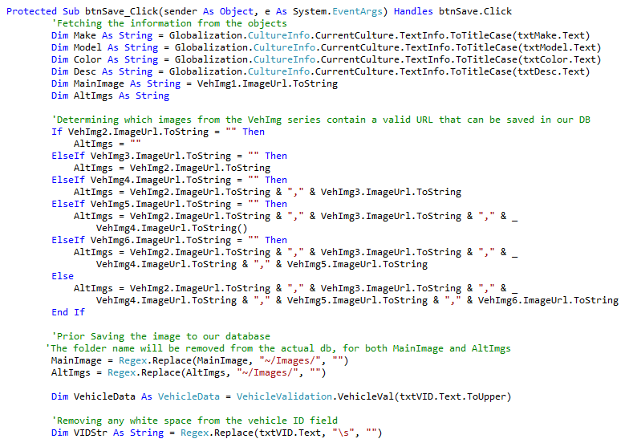

### Fig.29 – btnSave_Click - Part1

**Validation Points on btnSave_Click:**

1. We will now validate whether the vehicle ID (V_ID) entered by the user is already existent in our database. This validation will be processed through the "VehicleVal()" function found in the "VehicleValidation" class, this function (through a select statement) will take the vehicle ID inputted by the user and search through the "Vehicle" table. This function is illustrated in Fig.30.
2. Validation on all text boxes, drop down lists and other fields that require user input, will be validated accordingly. This validation will occur to avoid blank data and erroneous data.

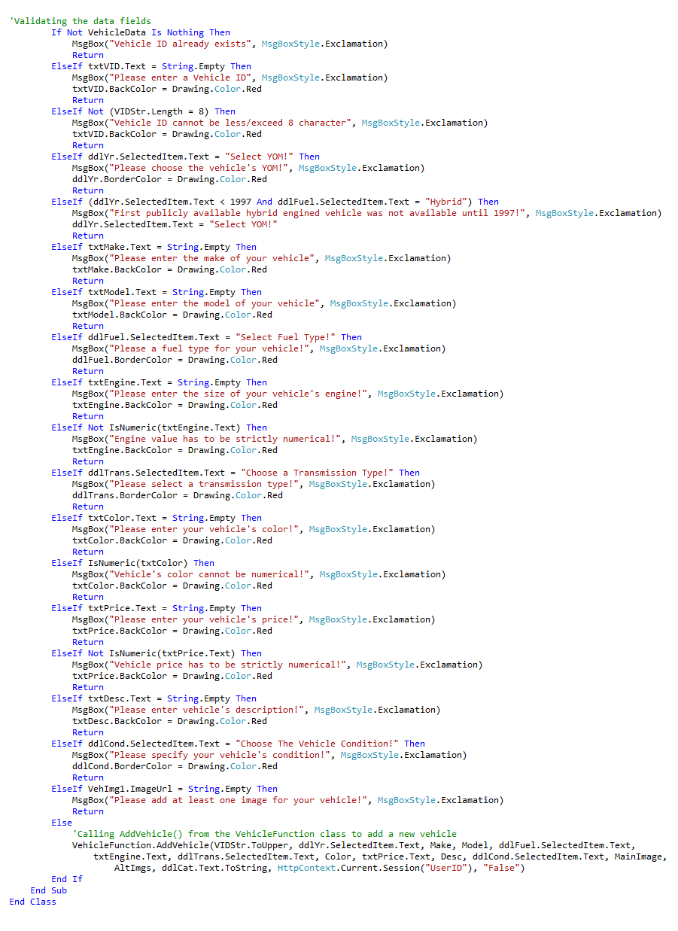

### Fig.30 – btnSave_Click - Part2

If all data will be correct, then after the validation process, the solution will carry on to actually add the vehicle to the "Vehicle" table. The function that will add the vehicle to the table is the "AddVehicle()" which is located in the "VehicleFunction" class. This function will update the "Vehicle" table with the data inputted by the user.

Fig.31 illustrates the "AddVehicle" function.

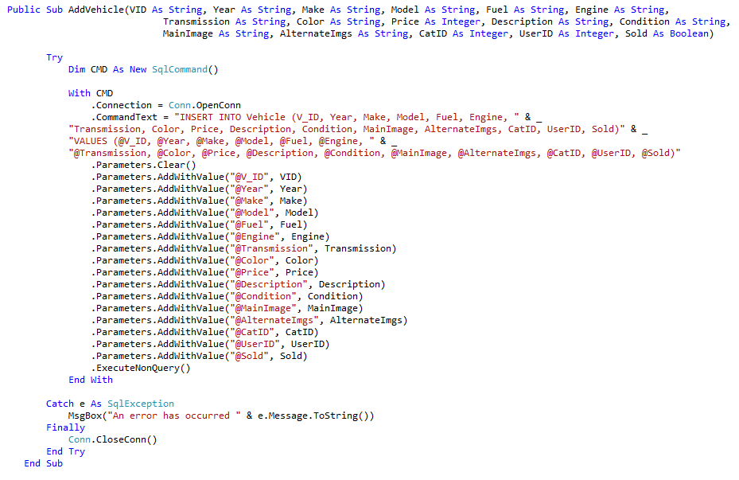

### Fig.31 – VehicleFunction.AddVehicle()

## Admin Panel Page – *(AdminPanel.aspx)*

This page or better this panel of the website contains a control panel for the administrator to control and manipulate the “*A & A Autotrading Limited”* website as needed. Once the administrator logs into the website he is directed to this panel and is presented with four buttons:-

“*Users*” button - populates a list of all the Users registered with the auto trading company

“*Vehicles*” button - populates a list of all the Vehicles within the company which can be deleted or selected for additional information

“*Categories*” button - populates a list of all the vehicle Category types found within the auto trading company and can be deleted, edited or added as required

“*Add Your Vehicle*” button - populates a list of all the Vehicles found at the auto trading company which can be added or deleted as required

The “*Admin Panel”* page can be accessed when an administrator logs in onto the website or uses the “*User Logged”* page whilst browsing within the website as it is featured and present throughout all the pages in the website, making the administrator experience much easier and pleasant to find his way around.

## Admin Panel Page – *(AdminPanel.aspx) - Back End Code*

### Part1 - AdminPanel - gvCategories_RowDeleting:

The below function will be used to validate, whether the category to be deleted is still associated with any vehicle, which if no will finally will result in deleting the selected category. The function that will actually delete the selected category from the "Category" table is the "Category Del" which may be accessed from the "CategoryFunction" class. Both " gvCategories_RowDeleting" and "CategoryDel" are shown in Fig.32 and Fig33 respectively.

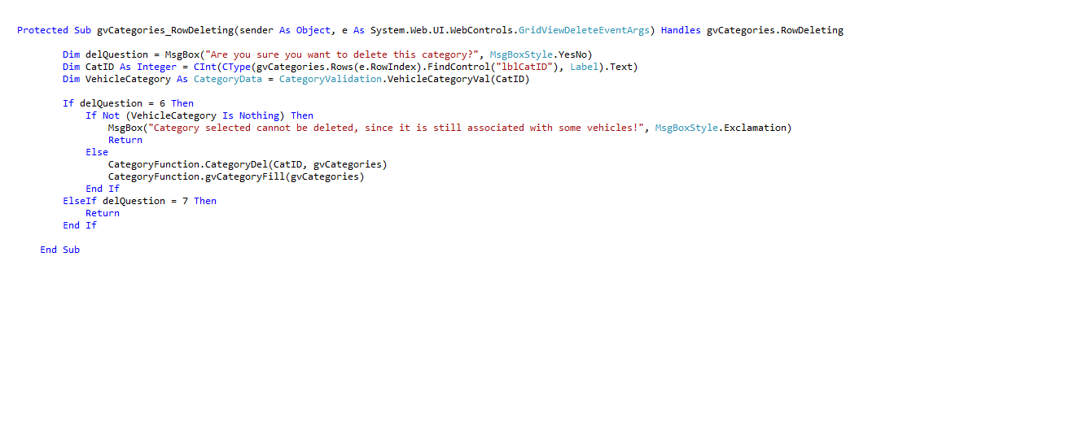

### Fig.32 – gvCategories_RowDeleting

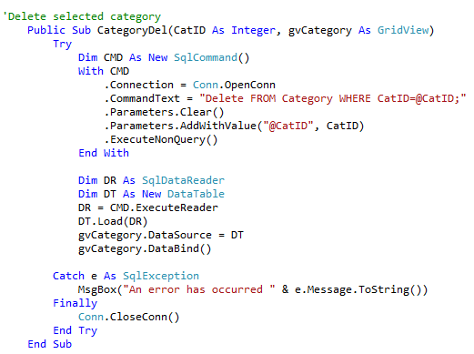

### Fig.33 – CategoryFunction.CategoryDel()

### Part2 - AdminPanel - gvCategories_RowUpdating:

The Admin will also be able to update/edit categories (one by one), this process is shown below in Fig.34.

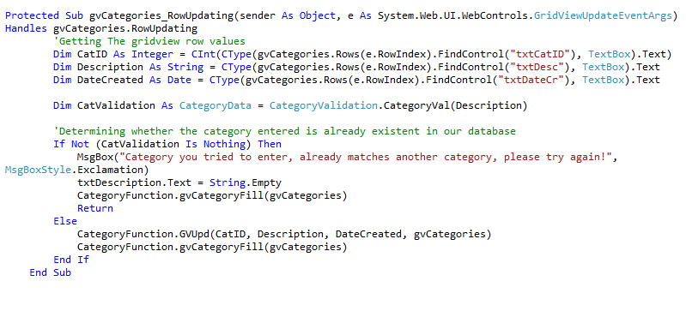

### Fig.34 – gvCategories_RowUpdating

The function "GVUpd" (illustrated in Fig.35), will use an update statement, which will retrieve the inputted category and update the category table accordingly.

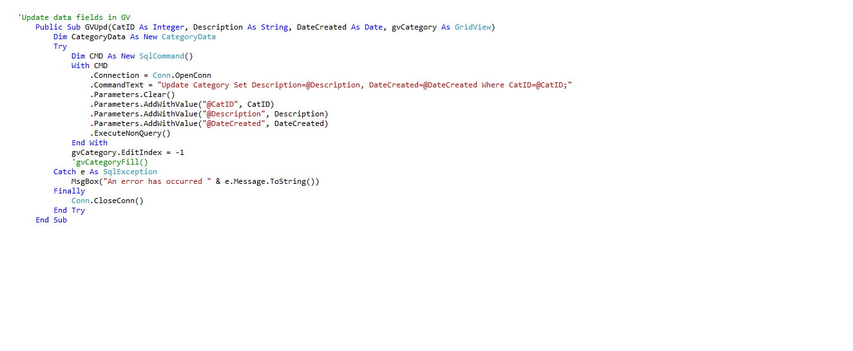

### Fig.35 – CategoryFunction.GVUpd()

### Part3 - AdminPanel - btnSave_Click:

Upon adding any categories "btnSave_Click", (shown in Fig.36) the inputted category will be validated and therefore these validation points will include:

**Validation Points on btnSave_Click:**

1. Will validate and verify whether the category to be saved already exists.
2. Will validate whether the "txtDescription" (category description) is left blank or not.

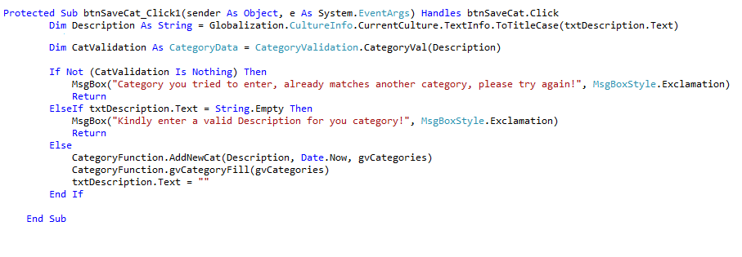

### Fig.36 – btnSaveCat_Click

Upon finishing the validating process then the "AddNewCat" function available in the "CategoryFunction" class will add the category accordingly. This function is displayed in Fig.37.

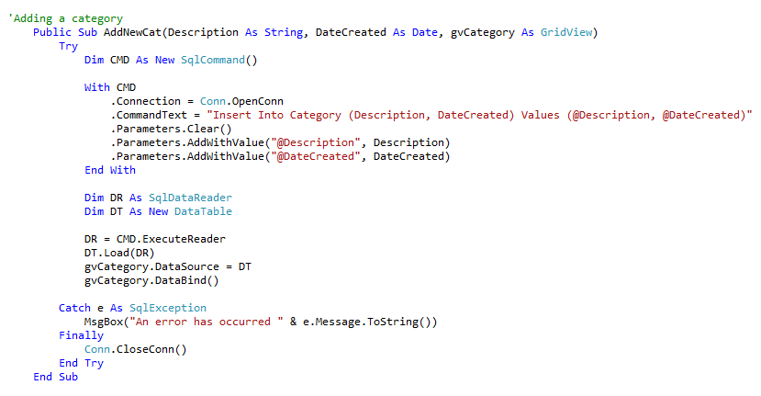

### Fig.37 – CategoryFunction.AddNewCat()

## Car Description Page – *(CarSingleView.aspx)*

This page of the website displays an in depth vehicle description and also additional photos of the cars which are found at “*A & A Autotrading Limited”.* This happens when a customer or an administrator selects a particular vehicle to view and is redirected to this page. The customer or administrator is redirected to this page when vehicles are selected to be viewed from the.

The “*Car Description”* page can be accessed from the “*New Cars”*, “*Used Cars”,* “*My Cars”*, “*Admin’s Panel*” and “*Search area”* pages respectively whilst the customer or the administrator is logged in onto the website and also from the “*New Cars”*, “*Used Cars” and* “*Search area”* pages when a non-registered customer is browsing within the website as they are featured and present throughout all the pages in the website making the customer and administrator experience much easier and pleasant to find his way around.

## Car Description Page – *(CarSingleView.aspx) - Back End Code*

This page will be used to display all the details for the selected vehicle either from the NewCars or from the UsedCars.

Below (in parts) one can find the business logic used in the "CarsSingleView" page.

### Part 1 -CarsSingleView - Page_Load:

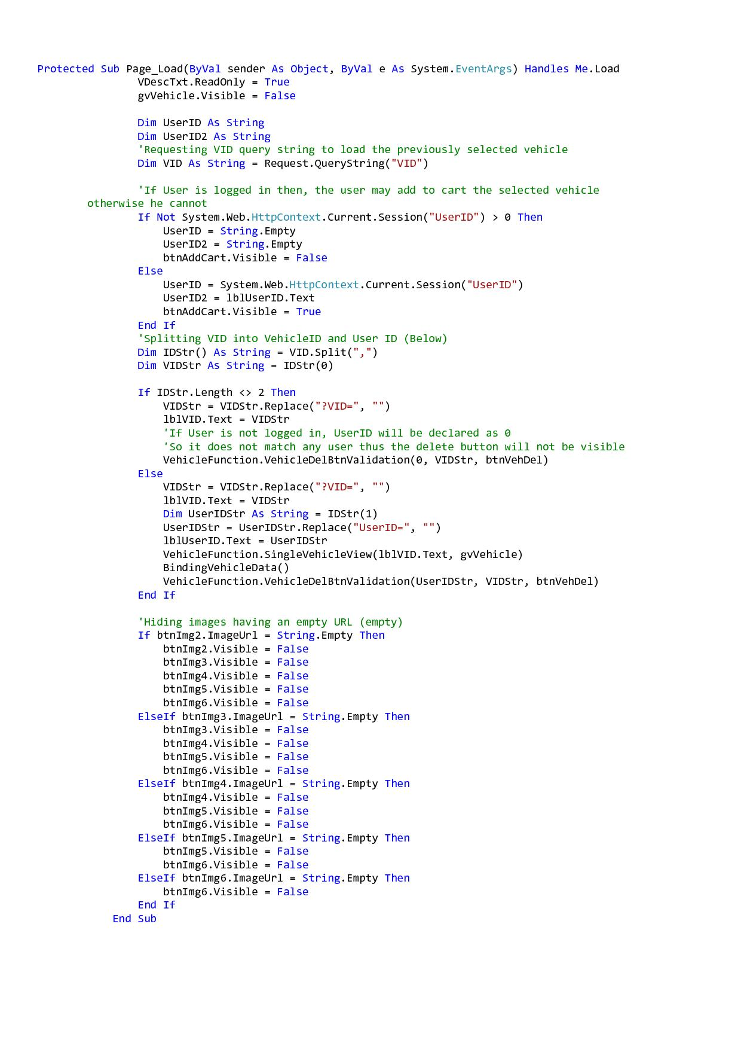

Fig.38 – CarsSingleView - Part1 - PageLoad

Firstly, we'll start by instantiating "ShoppingCartFunction" and "VehicleFunction", these will be both declared right after the declaration for the CarsSingleView class. By instantiating both classes globally will enable us to use them in the whole class and not limit us to use them just in a function or event only.

Secondly, we will being requesting the Vehicle ID which was passed from the previous page (either "NewCars" or "UsedCars") in order to get the selected vehicle and display its details in the CarsSingleView page, shown in Fig.39.



Fig.39 – Requesting the Vehicle ID

After displaying the selected vehicle we will be validating whether the user is logged in or not, thus if the user is logged in he/she may add the vehicle to the cart, but if not, the user will not be able to add any vehicles until logged in, this process is shown in Fig.40.

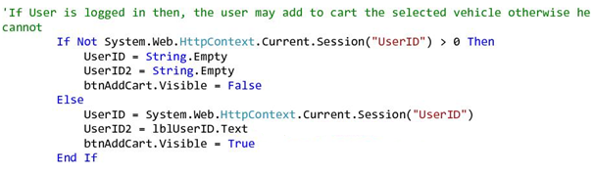

Fig.40 – Verifying if the user is logged in to avail btnAddToCart

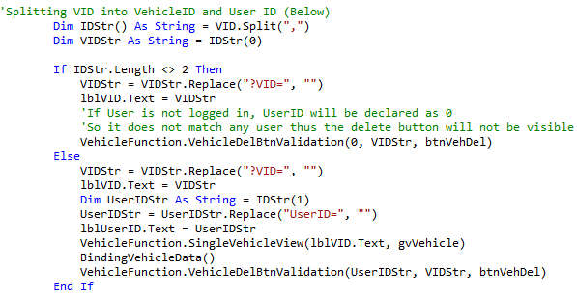

Fig.41 – Verifying UserID to enable the Delete Button

In Fig.41 we are illustrating the process where our program will split the requested vehicle ID shown in Fig.39. The vehicle ID string will contain both the VID and user ID, this is because we want to determine whether the current logged user is the one who created the selected vehicle. If the user matches as the person who created the vehicle then the delete button will be available for the user's perusal.

The "BindingVehicleData()" function, will be used to bind the data of the selected vehicle with the gridView in the current page. This function is explained in more detail below.

The below Fig.42, illustrates the process of hiding the image buttons that have an empty URL.

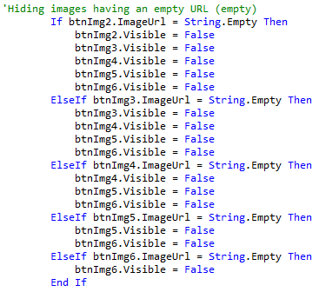

Fig.42 – Verifying UserID to enable the Delete Button

### Part 2 -CarsSingleView - BindingVehicleData():

The "BindingVehicleData()" function will be used assign the fields (text boxes, labels and main image) the data retrieved from the gridView (through gridView.FindControl). however the main image and other alternate images will be uploaded through the (AltImgBinding()) mentioned below in Fig.43.

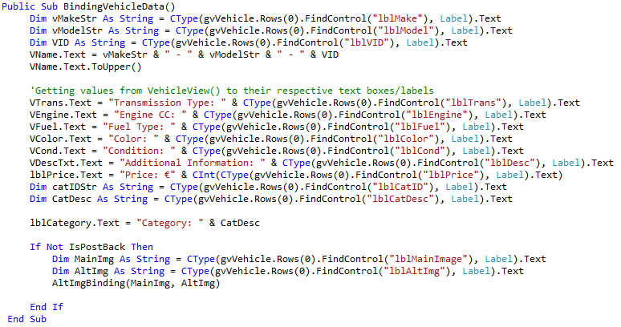

Fig.43 – BindingVehicleData()

### Part 3 -CarsSingleView - AltImgBinding():

This function will be used to load the images from the "Images" folder (stored in the solution), and to set the image size accordingly. The main image will be directly shown in the "LargeVImg" image button, whilst the other images (up to six images in total) will be uploaded in the smaller image buttons (btnImg2 - btnImg6). The alternate images will be stored as a comma delimited string (Jaguar XF - SideRear.jpg,Jaguar XF - Int.jpg,Jaguar XF - Front.jpg), then they will be split accordingly.

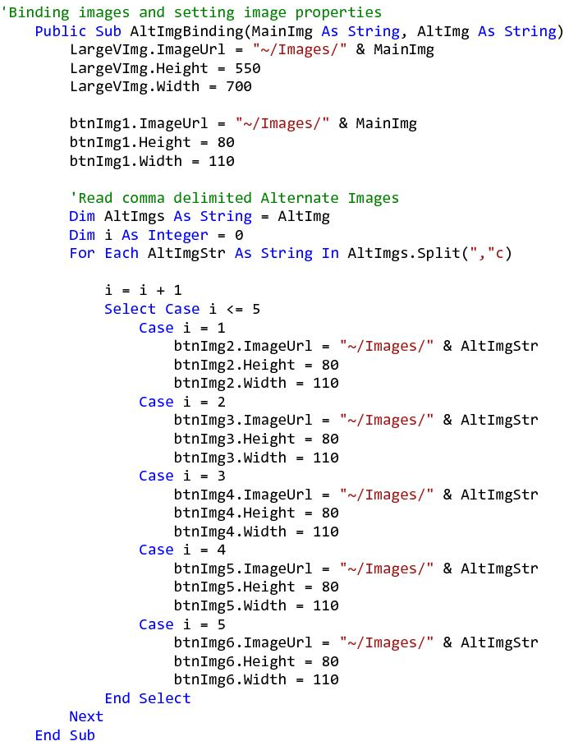

Fig.44 – AltBindingVehicleData()

### Part 4 - CarsSingleView - btnImg_Click:

The below events will fire once the button image (btnImg1-6), will be selected. Upon button click the selected button will be uploaded in the large image button (LargeVImg), for better viewing.

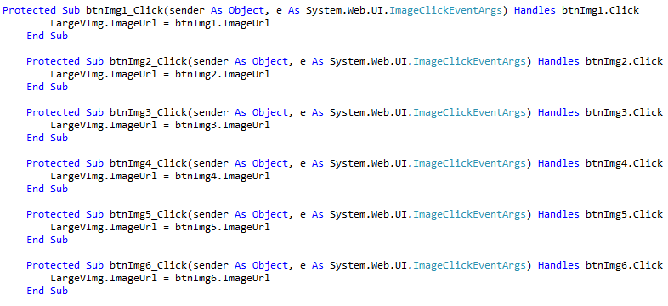

Fig.45 – btnImg_Click

### Part 5 -CarsSingleView - Deleting a vehicle:

The below event (which will be fired upon delete button (btnVehDel) click), will be used to delete a vehicle. Upon button click the user will be prompted to confirm the selected vehicle's deletion, if he presses the "Yes" button the "delQuestion" will return "6" as a value and will proceed to the "VehicleDel()" function. If the user presses "No" then the "delQuestion" will return "7" as a value and will stop the execution and return to "PageLoad()". Below in Fig.46 this process is illustrated accordingly, whilst Part 6 will define the "VehicleDel()" function.

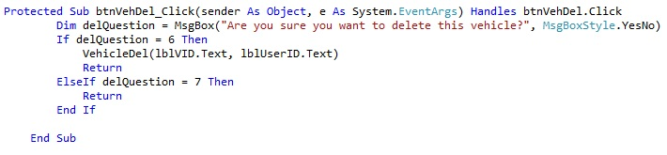

Fig.46 – AltBindingVehicleData()

Part 6 -CarsSingleView - VehicleDel()**:**

This functioned as already mentioned before, will be used to delete a vehicle. This function uses a "Delete" statement to delete the vehicle along with its images, obviously the images will also be deleted from the "Images" folder. This function is shown in Fig.47.

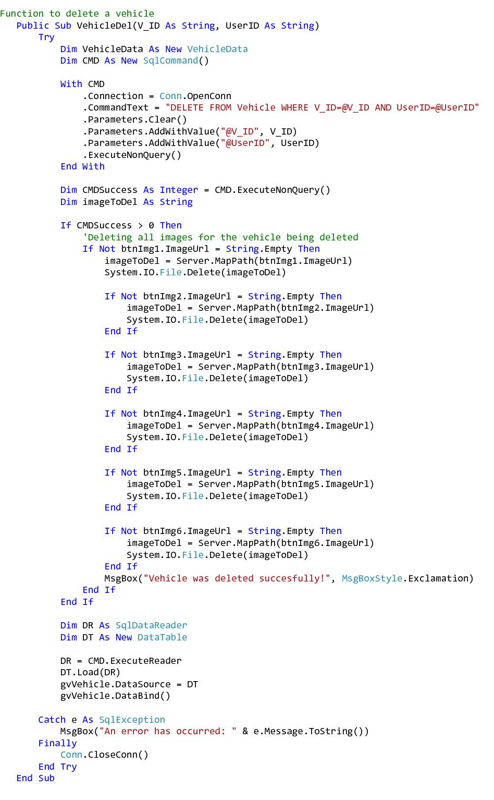

Fig.47 – AltBindingVehicleData()

Part 7 -CarsSingleView - btnAddCart_Click:

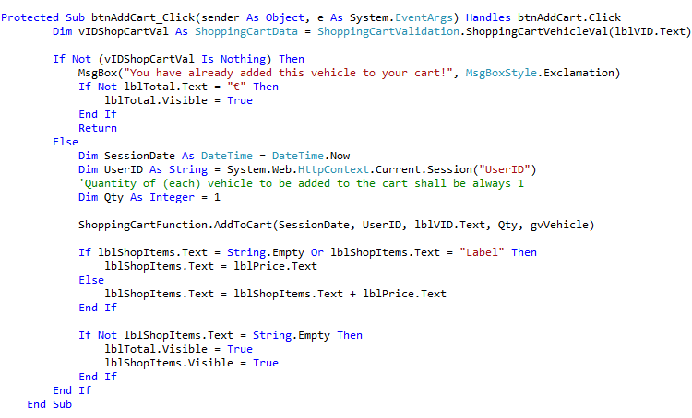

Fig.48 – btnAddCart_Click

The previous figure (Fig.48) shows the whole " btnAddCart_CLick" code below we will be explaining the whole code behind the button click event.

This event will fire when the user is logged in and clicks on the "Add to Cart" button namely "btnAddCart". However the user will not be able to click on the button if he's not logged in.

"vIDShopCartVal" will be created to validate the vehicle selected, therefore this instance will be used to access "ShoppingCartValidation" namely the "ShoppingCartVehicleVal". This functioned is described below.

### ShoppingCartVehicleVal:

Basically this function through a select statement will select the vehicle/s from the shopping cart where the vehicle ID matches, through an iteration. Shown in Fig.49.

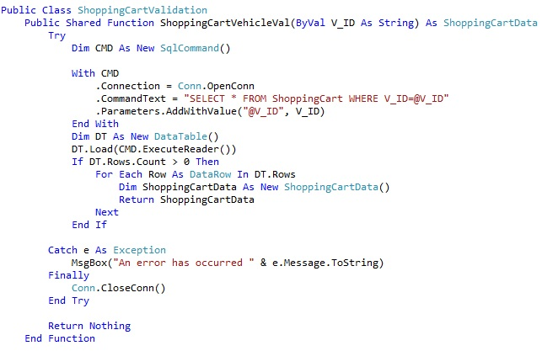

Fig.49 – ShoppingCartVehVal()

Through the ShoppingCartVehicleVal(), If the user has already added the vehicle to his cart, our solution will prompt him "That the vehicle is already added in his cart" and will stop execution of the program.

If the vehicle is not present in the user's cart, then the "ShoppingCartFunction.AddToCart()" function will be used to add the vehicle to the cart.

Therefore this function will use an insert statement to insert the selected vehicle/s to the shopping cart (table).

This function is illustrated in Fig.50, and may be accessed from our solution, "AppCode/ShoppingCartFunction/AddToCart().

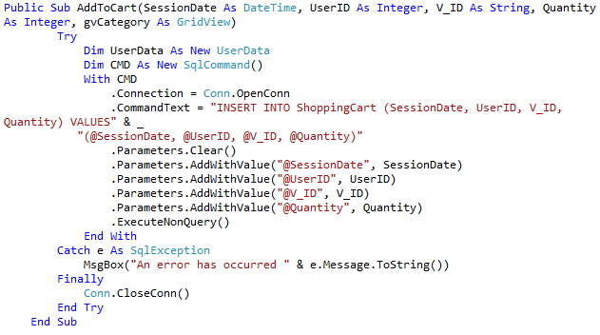

Fig.50 – AddToCart()

## Checkout Page – *(Checkout.aspx)*

This page of the website displays the final step prior to purchasing a vehicle from “*A & A Autotrading Limited”.* The customer is directed here once the logged in customer accesses his shopping cart after pressing the “*Checkout”* button from the “*Shopping Cart”* page and follows the re-Login verification procedure explained earlier in the “*Shopping Cart”* page. When he presses the “*Checkout”* button the car will be purchased and a “*Past Orders”* button will appear. This button gives the opportunity to the customer to track back previous vehicle orders if any are available.

The “*Checkout”* page can be accessed only when a customer logs in onto the website and has vehicles stored in his “*Shopping Cart”* page making the customer experience much easier and pleasant to find his way around.

## User Panel Page – *(UserPanel.aspx)*

This page or better this panel of the website contains a control panel for the customer to add a vehicle and put it up for sale at “*A & A Autotrading Limited”.* Once the customer logs into the website he is directed to this panel and is presented with the “*Add Your Vehicle*” button which when pressed will direct him to the “*Add Vehicle”* page where he would need to fill in the required template

The “*User Panel”* page can be accessed when an customer logs in onto the website or uses the “*User Logged”* page whilst browsing within the website as it is featured and present throughout all the pages in the website, making the customer experience much easier and pleasant to find his way around.

## User Panel Page – *(UserPanel.aspx) - Back End Code*

The "UserPanel" shown in Fig.51, will enable the user to add a vehicle, delete a vehicle and view his past orders.

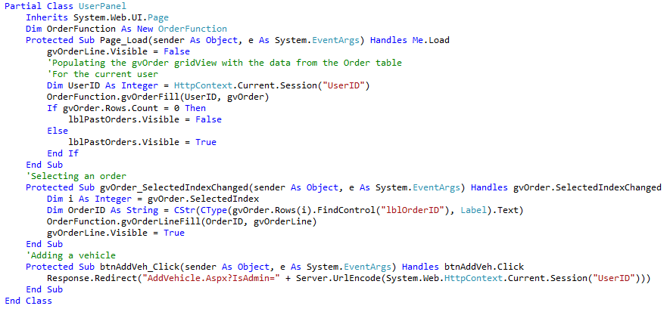

Fig.51 – UserPanel page

### Part1 - UserPanel - page_Load:

On page load, the solution will retrieve the "UserID" of the current user from the session, in order to be able to pass this ID to the "OrderFunction.gvOrderFill()" function. This function depicted in Fig.52 will be used to select all the orders, made by the current user (if any), and then populate the gridview with the results.

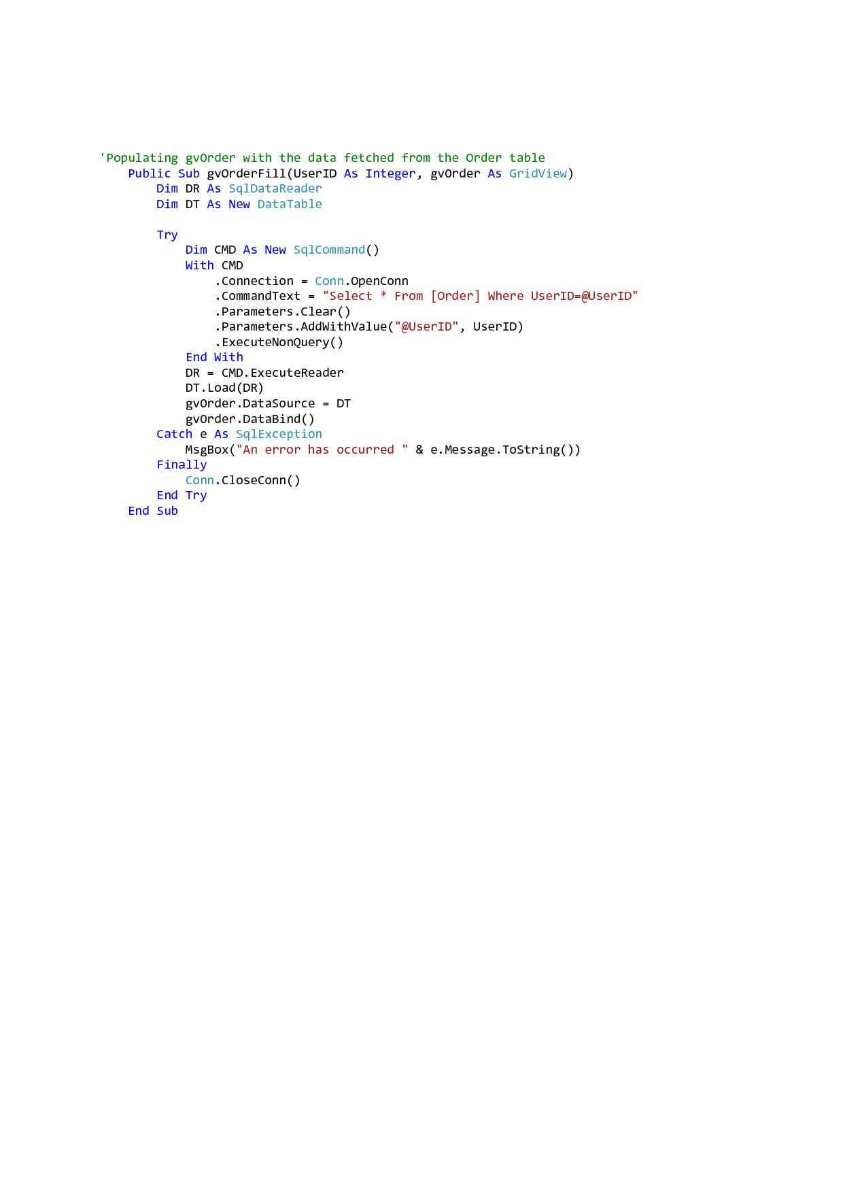

Fig.52 – OrderFunction.gvOrderFill() Function

### Part2 - UserPanel - gvOrder_SelectedIndexChanged:

After the "gvOrderFill()" function was executed and the "gvOrder" was populated accordingly with the results, the user may now select an order from the same gridview. The selected order will then be populated in the "gvOrderLine" gridview.

### Part3 - UserPanel - btnAddVeh_Click:

This event will fire when the user clicks the add vehicle button, namely "btnAddVeh". This snippet will then redirect the user to the "AddVehicle" page and will encode the "IsAdmin" string which contains the "UserID", to be later validated in the "AddVehicle" page. This feature is also available in the "AdminPanel" so that the administrators will be able to add vehicles.

# Website Additional Files and Database

## Database

In this section we will document and illustrate the database we designed for this coursework.

Our database name is "**BIS2212-CW4**", it consists of six tables as mentioned below:

* Category
* Order
* OrderLine
* ShoppingCart
* User
* Vehicle

A detailed explanation for each table can be found below.

## User Table:

The User table will be used to hold user information, such as name, user name, password, etc. Shown below in Fig.53 is the data structure of the User table and the data types respectively.

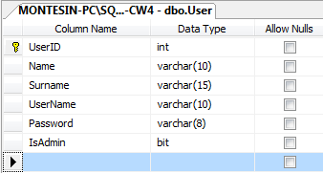

### Fig.53 – User Table

The IsAdmin property in the User table will be used to identify whether a user is an administrator or not, the IsAdmin is of bit data type, which takes either 1 or 0 or True/False.

The figure below (Fig.54) shows the User table populated with records.

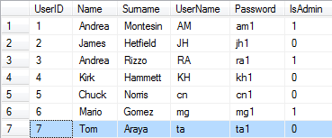

### Fig.54– Populated OrderLine Table

## ShoppingCart Table:

The shopping cart table will be used as a temporary table, therefore the user will add a vehicle to this table, the vehicle selected will stay in the ShoppingCart until the user decides to either buy the vehicle or removes it.

Shown below (in Fig.55) one can find the table structure (columns and their data types respectively) of the Shopping Cart.

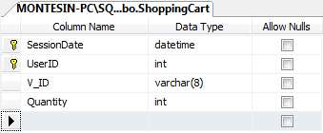

### Fig.55 – ShoppingCart Table

Columns:

* SessionDate - The time and date the user added the vehicles to the cart.
* UserID - The (unique) user identification number for that respective user.
* V_ID - A unique vehicle identification number.
* Quantity - Since the V_ID is unique, the quantity of a vehicle added to the cart shall be always single (1).

Fig. 56 shows the ShoppingCart table populated with two vehicles.

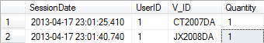

### Fig.56 – Populated ShoppingCart Table

## Order Table:

As soon as the vehicles have been bought, an order will be created, thus the Order tables will be used to hold data about the orders processed.

The columns and their data types for the Order table are shown below (Fig.57).

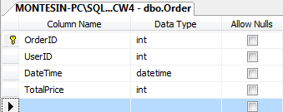

### Fig.57 – Order Table

Columns:

* OrderID - A unique (order) identification number.
* UserID - The (unique) user identification number for that respective user.
* DateTime - The time and date the order was placed.
* TotalPrice - The total price for the particular order.

Fig.58 shows the Order table populated with a single order.

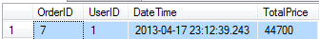

### Fig.58 – Populated Order Table

## OrderLine Table:

After the order is created the OrderLine Table will be populated with the data derived from the Order table. Therefore, depending if the user order two vehicles, then two OrderLine tuples will be created. The OrderLine is made up of the below mentioned columns (Fig.59)

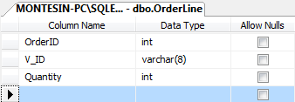

### Fig.59 – OrderLine Table

Columns:

* OrderId - The unique Order number.
* V_ID - A unique vehicle identification number.
* Quantity - Since the V_ID is unique, the quantity of a vehicle added to the cart shall be always single (1).

A populated OrderLine Table will look as the one in Fig.60.

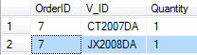

### Fig.60 – Populated OrderLine Table

## Category Table:

The category table will be used to categorise the different types of vehicle, for example a family car is different from a sport vehicle, so the category table will be used as an intermediary in order to allow identification between the different types of vehicles.

Illustrated in Fig.61 one can find the Category table structure, including the column names and their data types respectively.

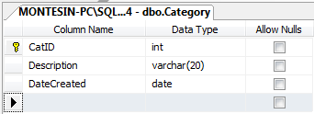

### Fig.61 – Category Table Structure

Once populated with data the category table will look as in the below figure Fig.62.

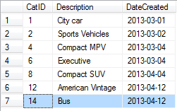

### Fig.62 – Populated Category Table

## Vehicle Table:

The Vehicle table will hold all the relevant information about the vehicles listed in the website. This table is made up of various vehicle properties such as fuel type, transmission, price, condition, etc. These properties will be used to define the vehicle.

The Vehicle table data structure is illustrated below in Fig.63.

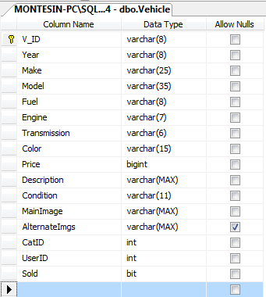

### Fig.63 – Vehicle Table Structure

Columns:

* MainImage - Will be used to hold the path for the (user chosen) main image
* AlternateImgs - If the user decides to add more images other than the main image, this property will be used to hold the path for each alternate image.
* Sold - Upon vehicle creation the Sold property will be declared "False" since the vehicle has not been sold yet. If the Vehicle is bought than the Sold property will be updated to "True", so as to avoid relisting the vehicle when as we said before the quantity for each vehicle is 1.

The Vehicle table once populated will look as in Fig.64.

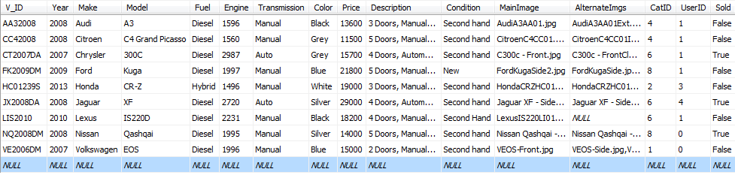

### Fig.64– Populated Vehicle Table

## Connection

Fig.65 illustrates the opening and closing connection function that was used to connect our website with the SQL server.

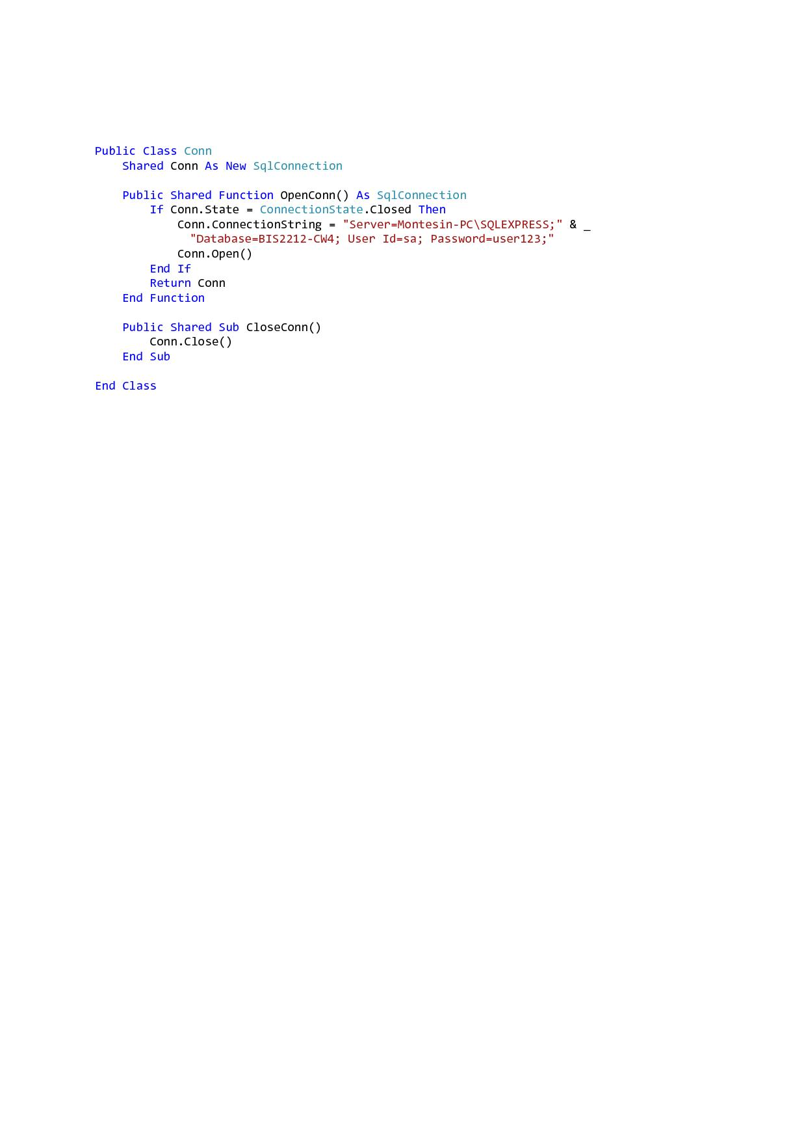

### Fig.65– Conn.OpenConn() & Conn.CloseConn()

**NB: Should one need to run our website on a different computer, the ConnectionString, should be modified accordingly, and the database backup must be installed on you SQL server.**

## Cascading Style Sheets (CSS)

Below is some of the main CSS code used for styling most of the content found on the *MasterPage.master* page which was used as the base template for all the *.aspx* pages within the “*A & A Autotrading Limited”* website.

### Body CSS:

This CSS styles the whole content (whole website) found within the *body* element styling any general page text font, background gradient color, and page height for all the pages within the website.

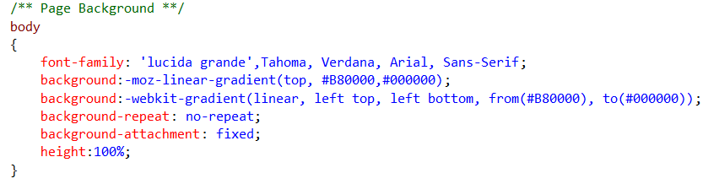

### Fig.66– Body CSS

### Wrapper CSS:

This CSS sets and styles the content found in the div *wrapper* container and the *body* element container respectively. The styling sets the margins top / bottom / left and right, padding around the div container, and the background together with a border around the same container.

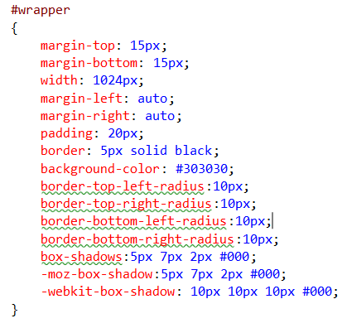

### Fig.67– Wrapper CSS

### Top Bar CSS:

This CSS sets and styles the bar area and content within the div *top_bar* container and the div *wrapper* container respectively. The styling sets the height, borders and padding around the div container, and the background gradient together with shadow effects around the same container.

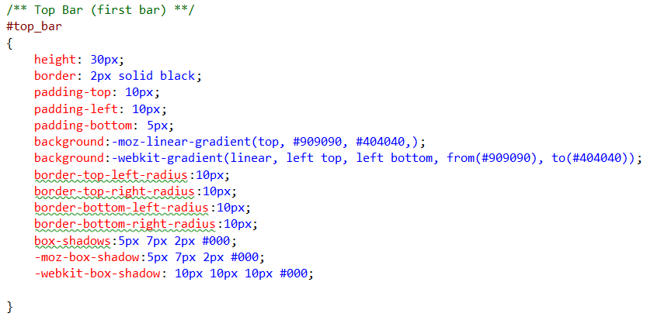

### Fig.68– Top Bar CSS

### lblSearch / txtbSearch / btnSearch CSS:

This CSS sets and styles the *Search* label, textbox and button located in the div *top_bar* container and the div *wrapper* container respectively. The styling sets the color, weight, size, style and family of the font the text each of them have.

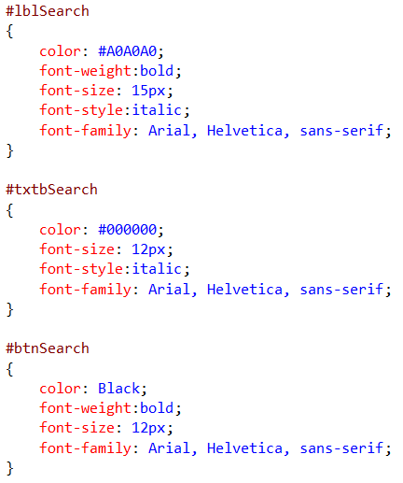

### Fig.69– lblSearch / txtbSearch / btnSearch CSS

### Top Shop Cart CSS:

This CSS sets and styles the *Shopping Cart* image located in the div *top_bar* container and the div *wrapper* container respectively. The styling sets the list style, margins, the hover feature (changing the image opacity), the height, and image padding and floatation location.

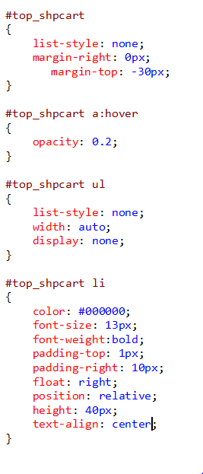

### Fig.70– Top Shop Cart CSS

### Top Reg Log CSS:

This CSS helps set and style the *Register, Login, Logged in as and Logout* menu that are located in the div *top_bar* container and the div *wrapper* container respectively. The styling sets the list style, margins, the hover features (changing the image colors), the height, the margins, the image padding, the text fonts and decoration together with the floatation location.

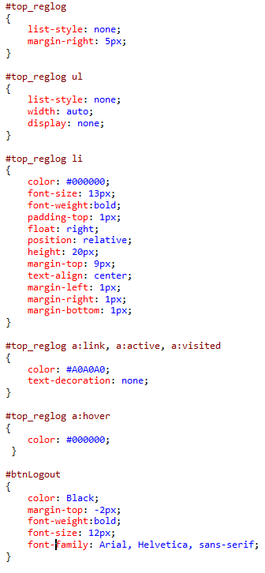

### Fig.71– Top Reg Log CSS

### Banner CSS:

This CSS helps set and style the image that is located in the div *banner* container and the div *wrapper* container respectively. The styling sets the margins, height, the border, shadow effects, the background image styling and the hover and opacity effects (changing the opacity when hovered over)

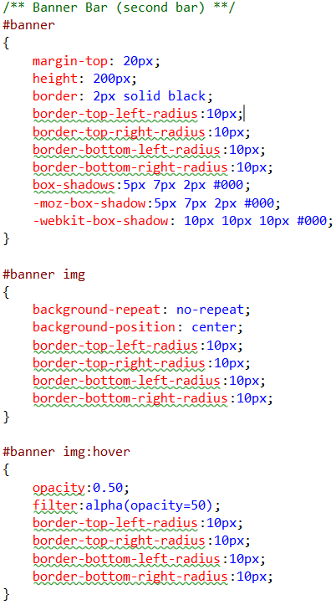

### Fig.72– Banner CSS

### Menu CSS:

This CSS helps set and style the menu that is located in the div *menu_bar* container and the div *wrapper* container respectively. The styling sets the list style, margins, the hover features (changing the image colors), the borders, the height, the margins, the image padding, the text fonts and decoration, the background gradients and shadows effects together with the floatation location.

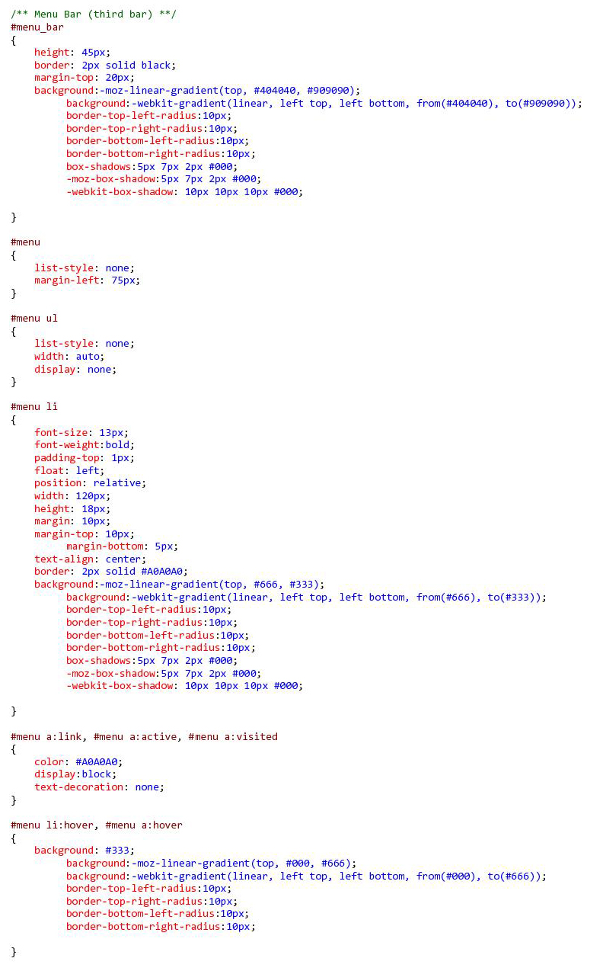

### Fig.73– Menu CSS

### Content Area CSS:

This CSS helps style the content that is located in the div *content_area* container and the div *wrapper* container respectively. The styling sets the margins, the border and padding effects, the background image settings, the container shadow effects and any paragraph text color, alignment and padding.

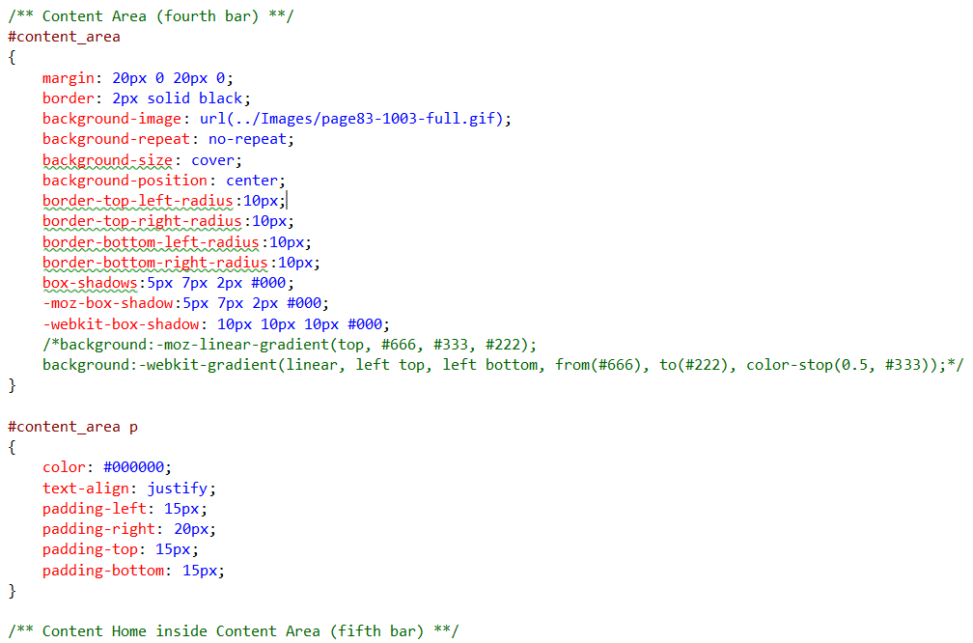

### Fig.74– Content Area CSS

### Content Home CSS:

This CSS helps style the content place holder (which is the only content that is changed in the other pages within the website) and that is placed in the div *content_home container* that is in itself located within the div *content_area* container and the div *wrapper* container respectively. The styling sets the margins, the border and padding effects, the width and height and also the background image settings together with any generic fieldset / legend styling.

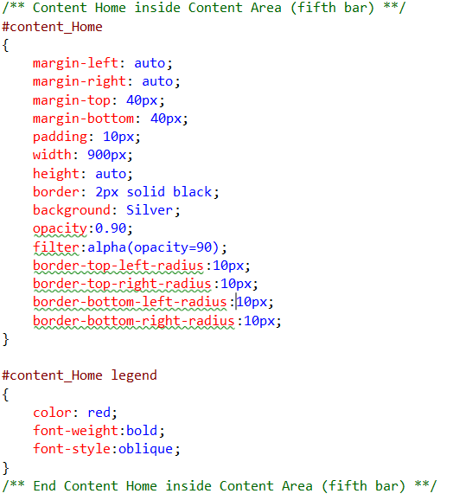

### Fig.75– Content Home CSS

### Footer Bar CSS:

This CSS helps style the footer bar that is placed within the div *footer_bar container* that is located within the div *wrapper* container. The styling sets the height, the border, padding, the background gradient settings together with shadow effects and paragraph text color, font weight, size, style and alignment.

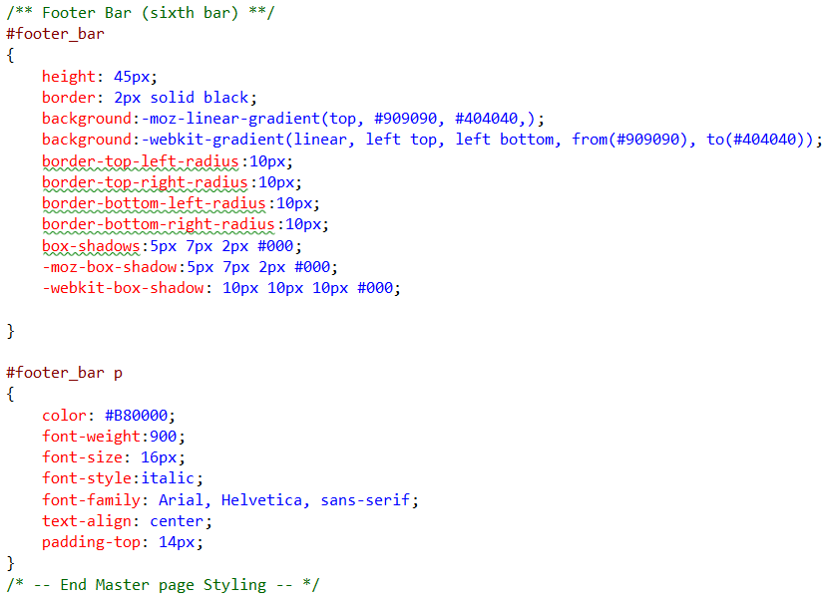

### Fig.76– Footer Bar CSS

# Website Images and Information:

The table mentioned below illustrates the sources of information that were used for vehicle images and their description.

***N.B.*** *- We do not own any images or vehicle descriptions found in our website, therefore credit is to be given to their respective owners (the ones mentioned in the website images and information table).*

|  |  |  |
| --- | --- | --- |
| Company | Image | URL |
| UK To Malta | Vehicle Description (all of them) | <http://www.uktomalta.com/home> |
| Google | Vehicle Images | <http://www.google.co.uk> |
| Auto Trader | Vehicle Images / Description | <http://www.autotrader.co.uk/> |
| Park Place Texas | Vehicle Images | <http://www.parkplacetexas.com/> |
| The Car Connection | Vehicle Images | [http://www.thecarconnection.com](http://www.thecarconnection.com/) |

### Website Images and Information Table

# Website Screen Shots (Functionality)

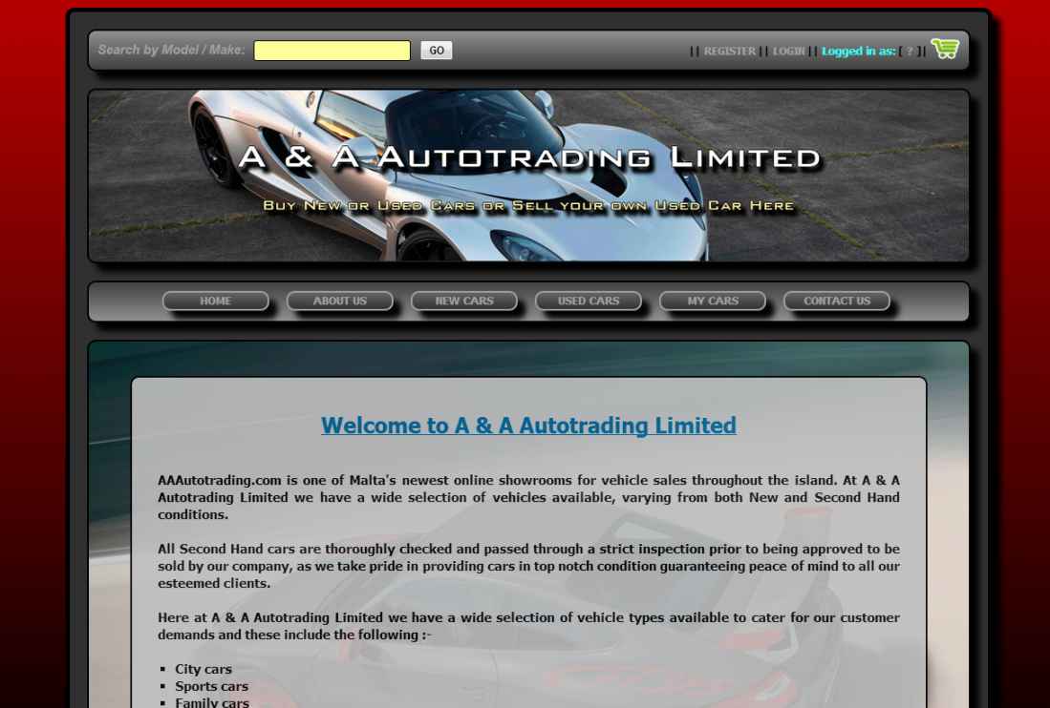

### Fig.77 – Home Page



### Fig.78 – About Us Page

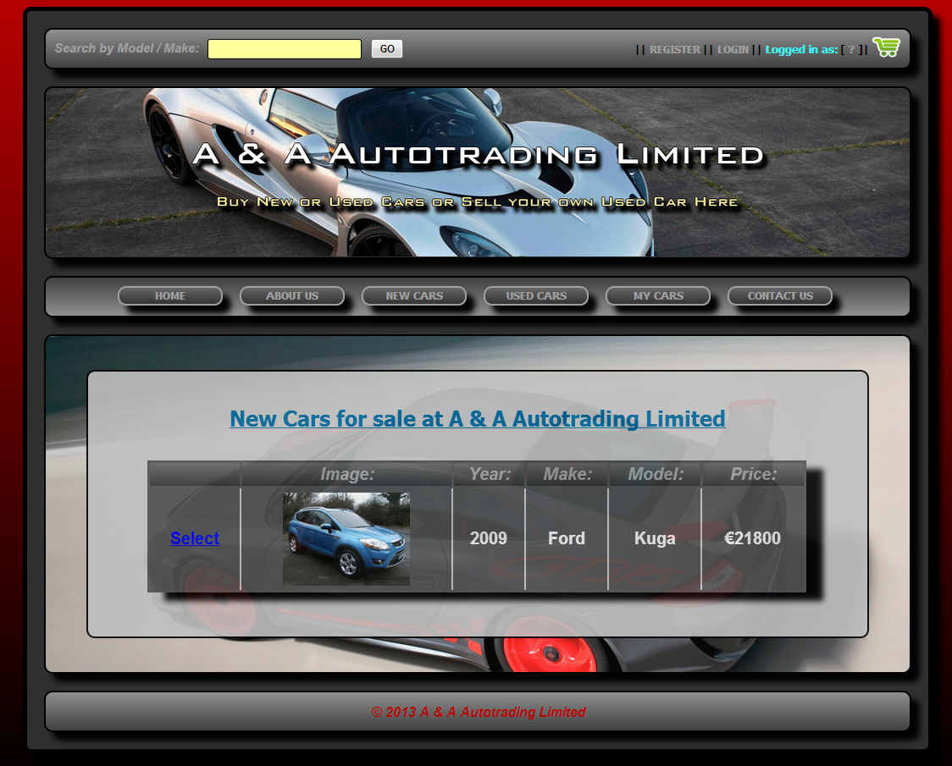

### Fig.79 – New Cars Page

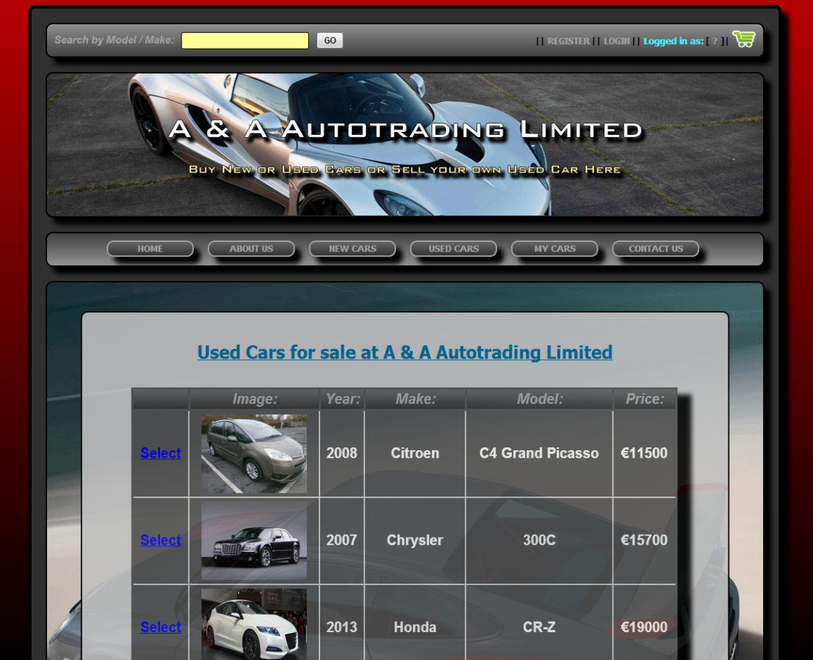

### Fig.80 – Used Cars Page

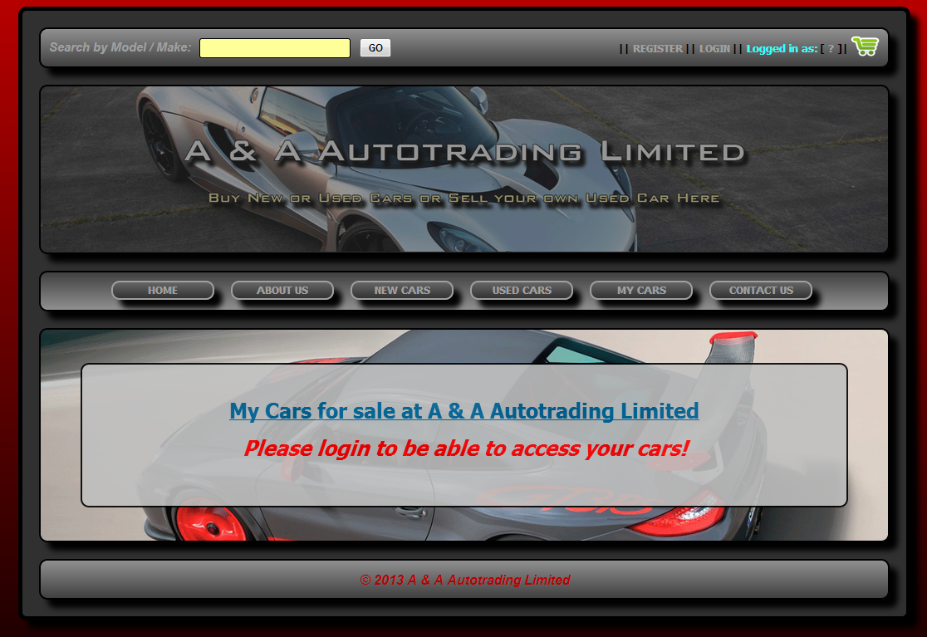

### Fig.81 – My Cars Page (Not logged in)

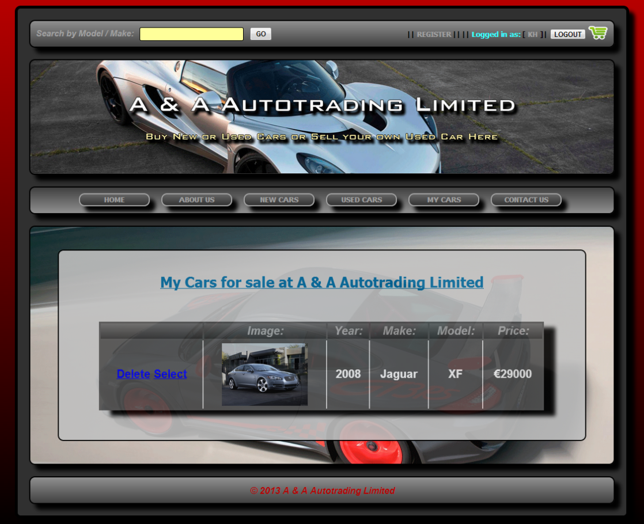

### Fig.82 – My Cars Page (Logged in)

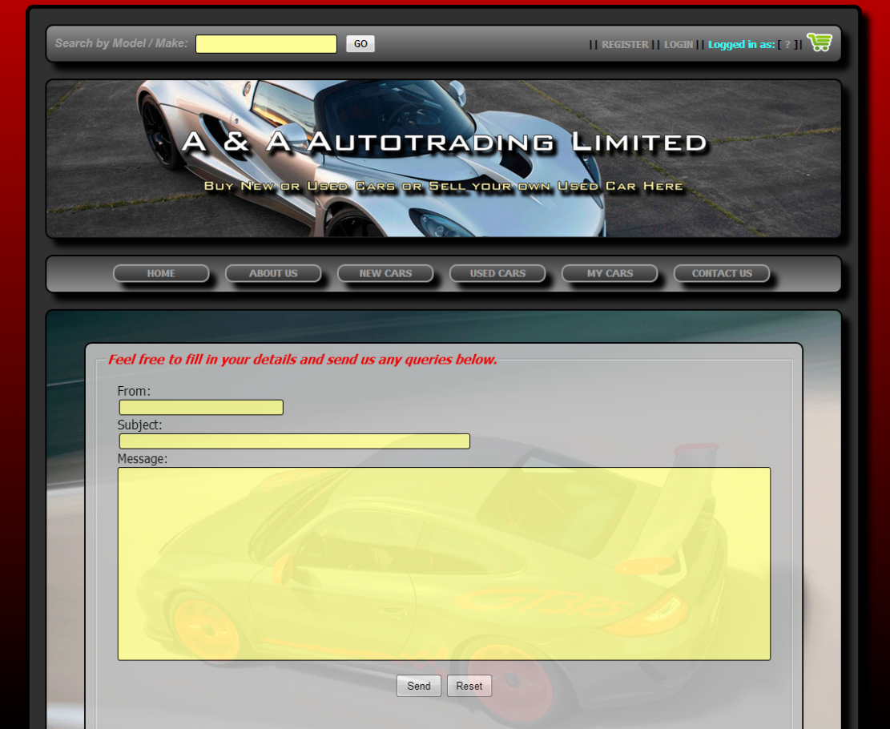

### Fig.83 – Contact Us Page

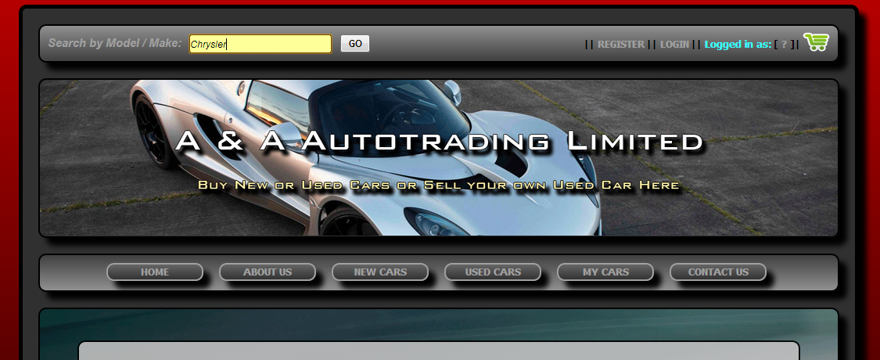

### Fig.84 – Search Area (search for Chrysler Make)

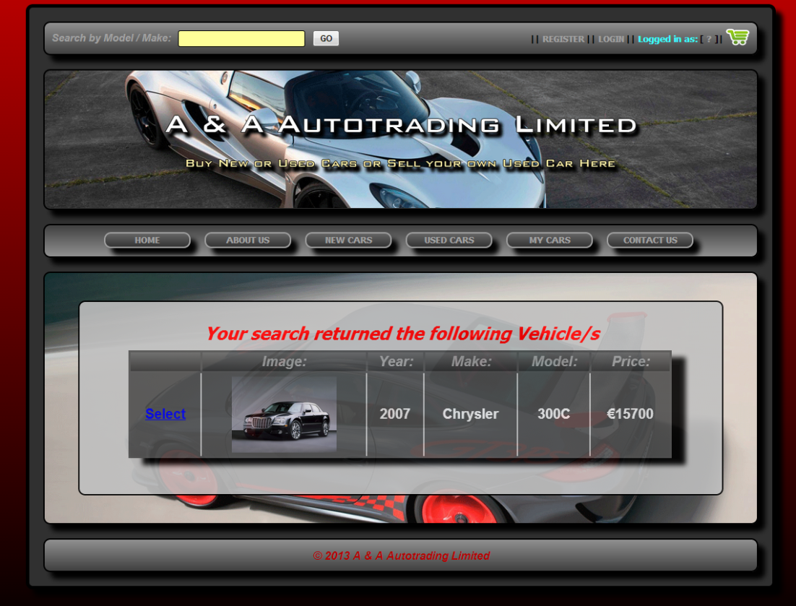

### Fig.85 – Search Area (Returned Chrysler Make)

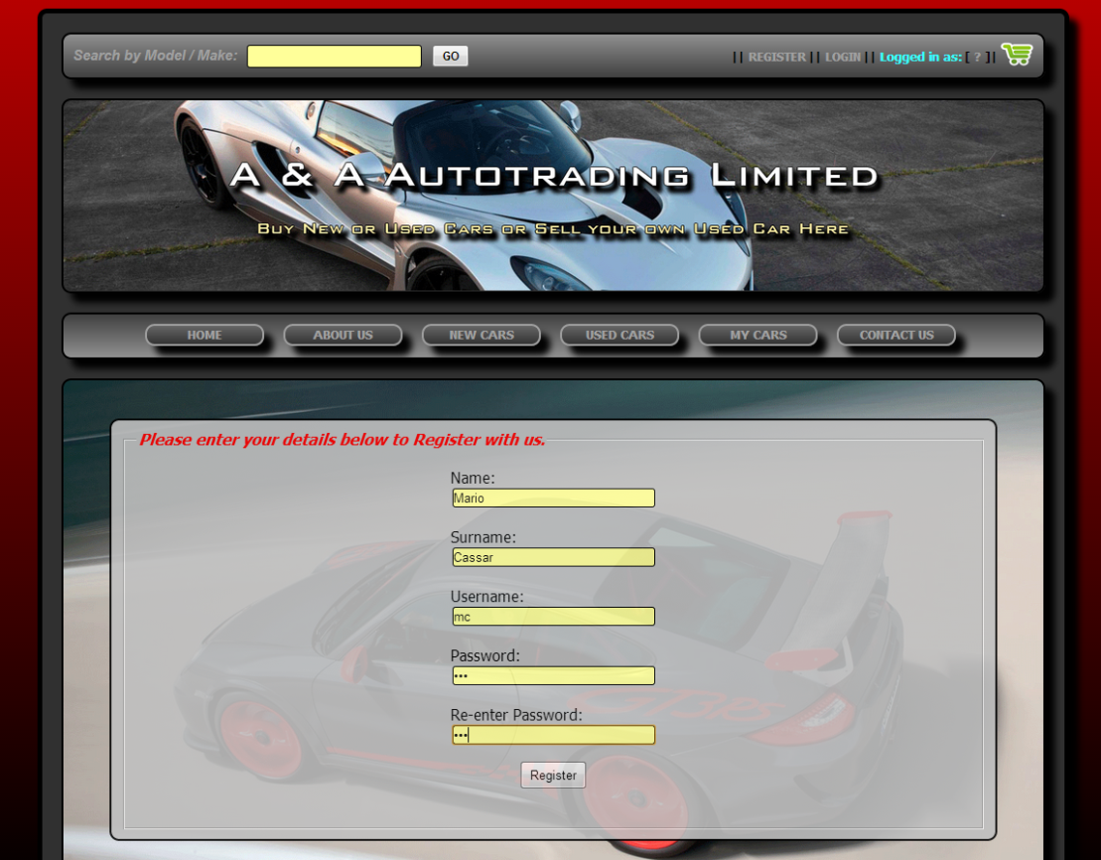

### Fig.86 – Registering Customer

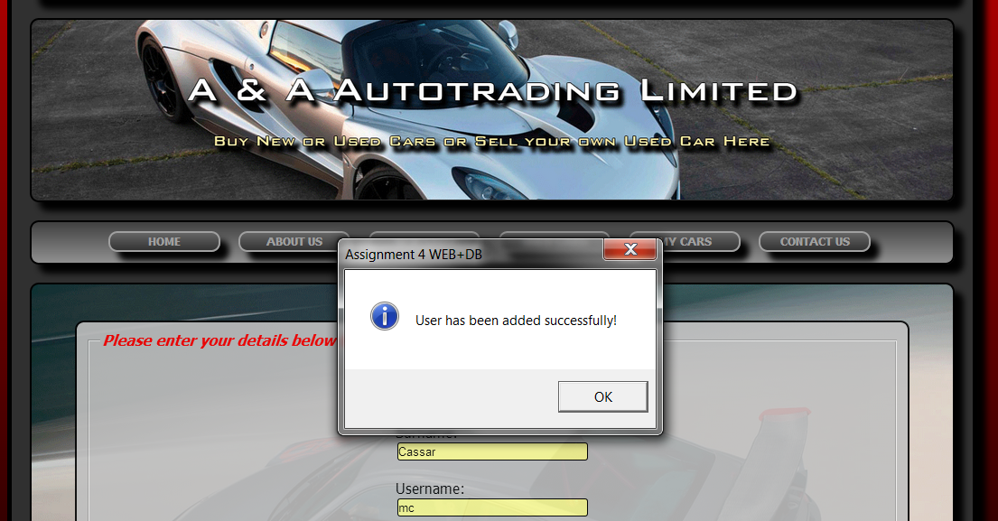

### Fig.87 – Registering Customer (Successful)

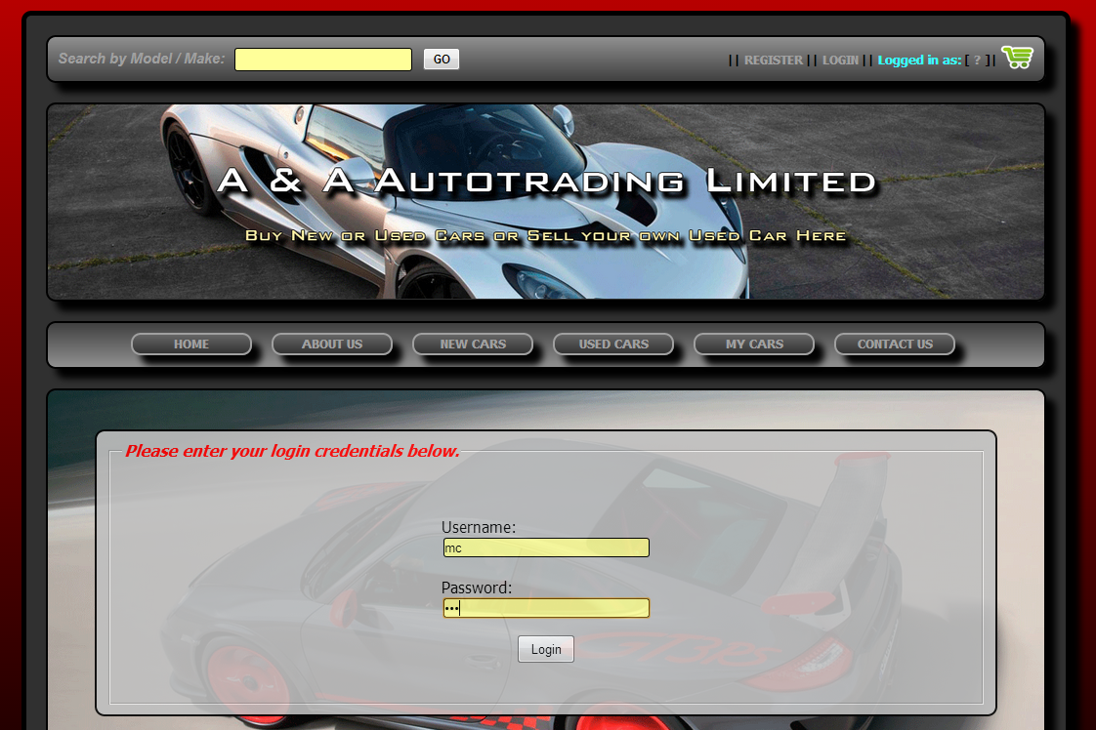

### Fig.88 – Login Customer (Username: MC Password: MC1)

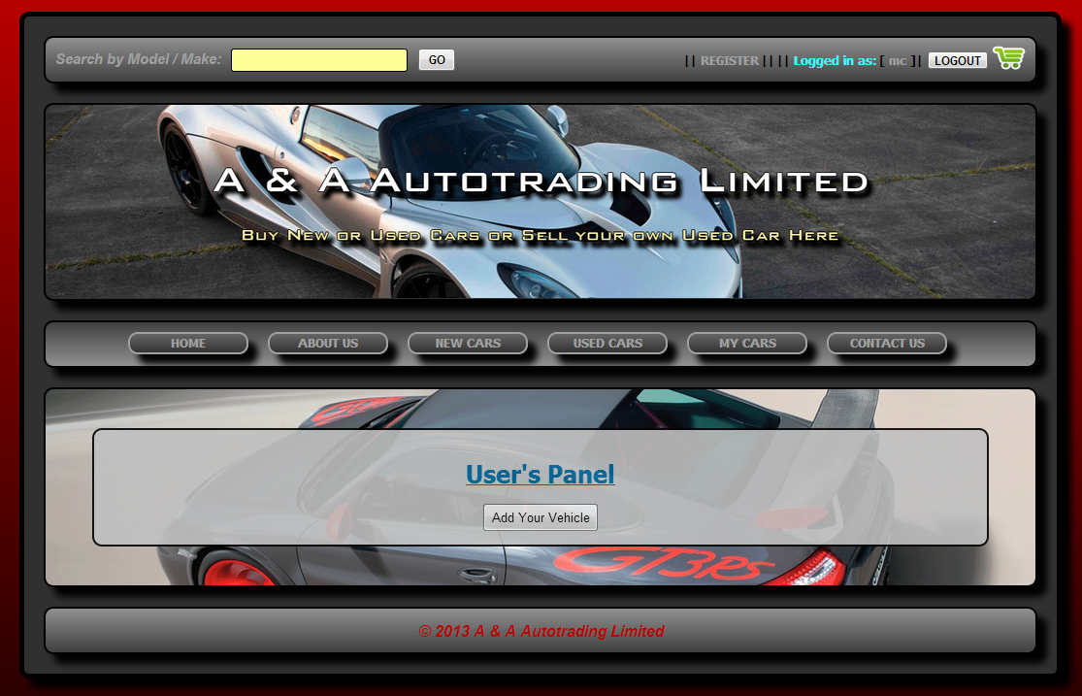

### Fig.89 – Login Customer (Username: MC Successful)

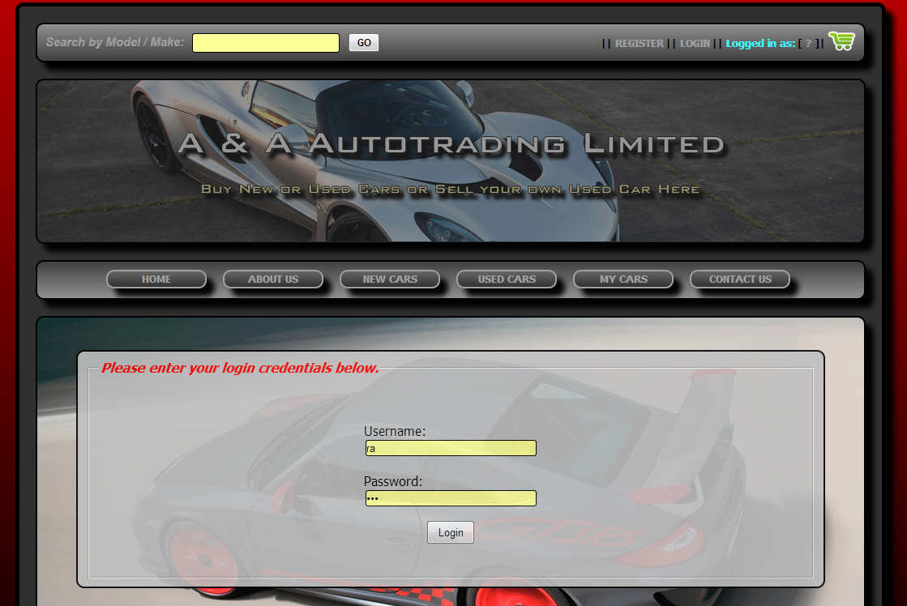

### Fig.90 – Login Administrator (Username: RA Password: RA1)

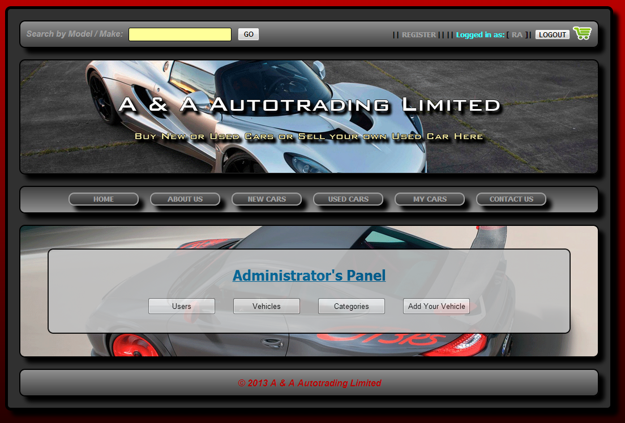

### Fig.91 – Login Administrator (Username: RA Successful)

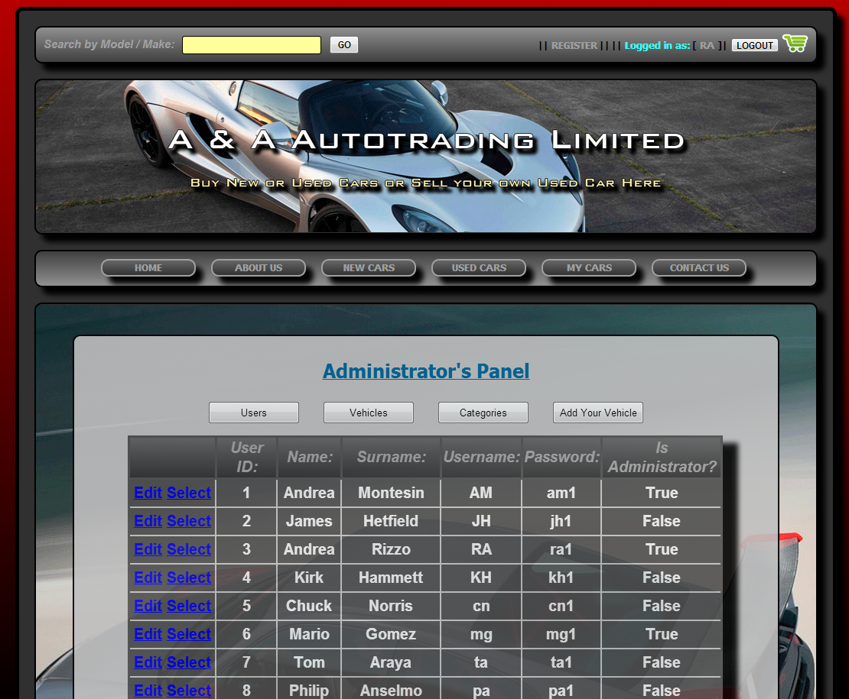

### Fig.92 – Users List from Admin’s Panel

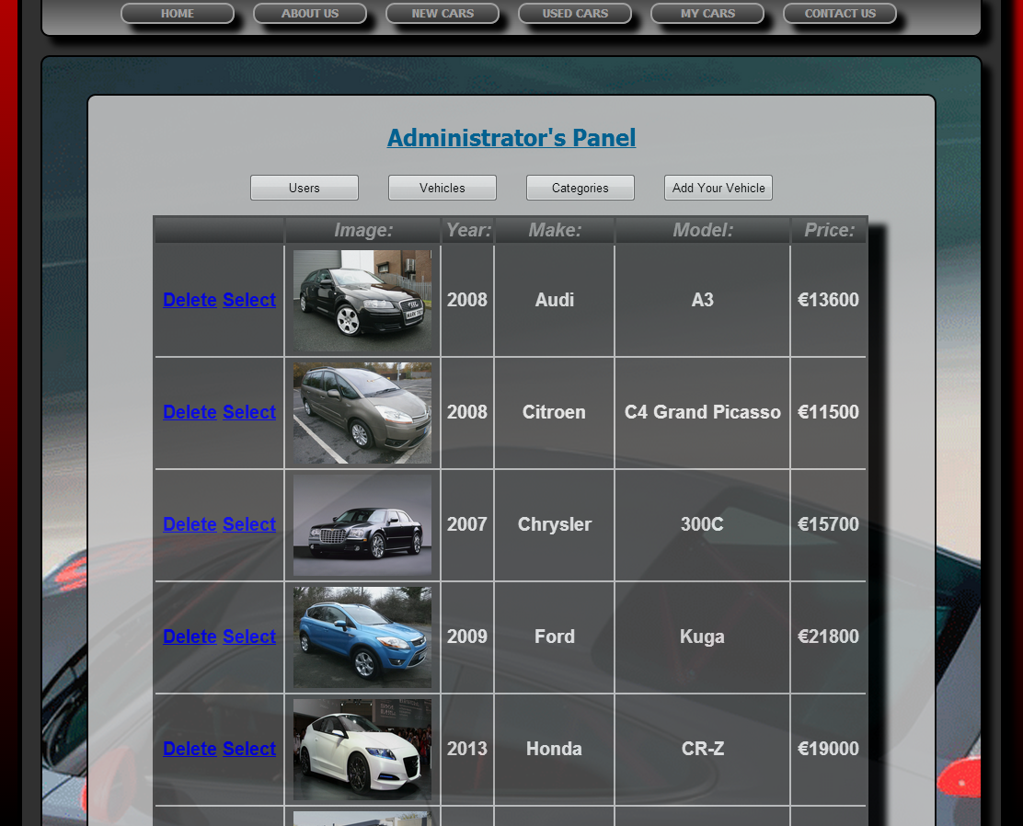

### Fig.93 – Vehicles List from Admin’s Panel

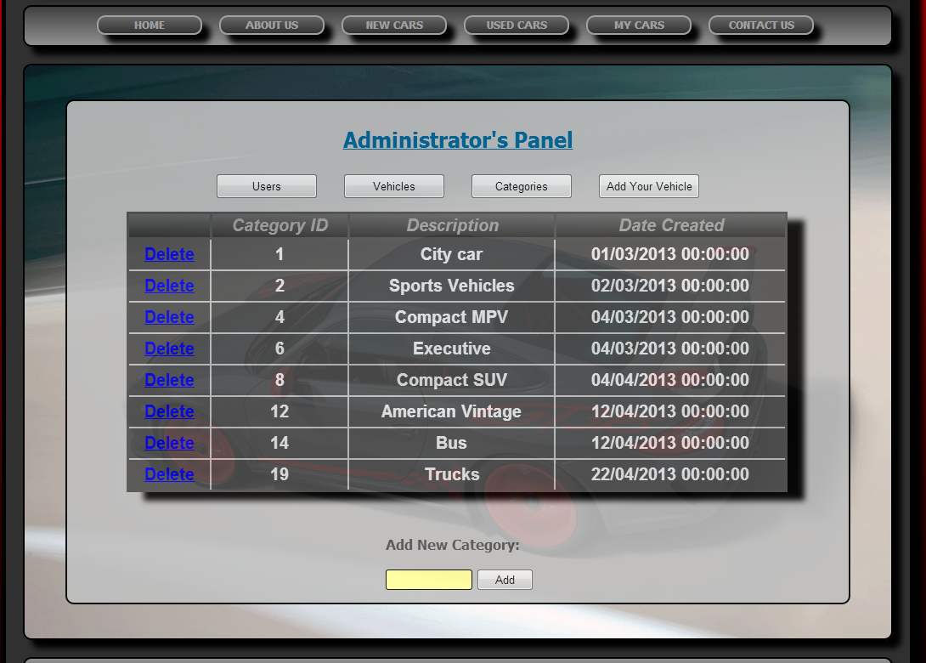

### Fig.94 – Vehicles List from Admin’s Panel

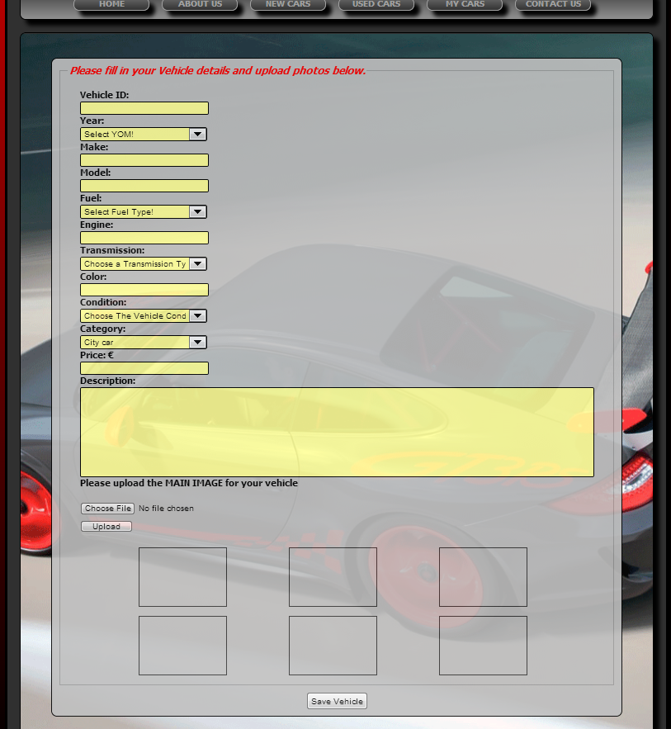

### Fig.95 – Add new Vehicle template form from Admin’s / User’s Panel

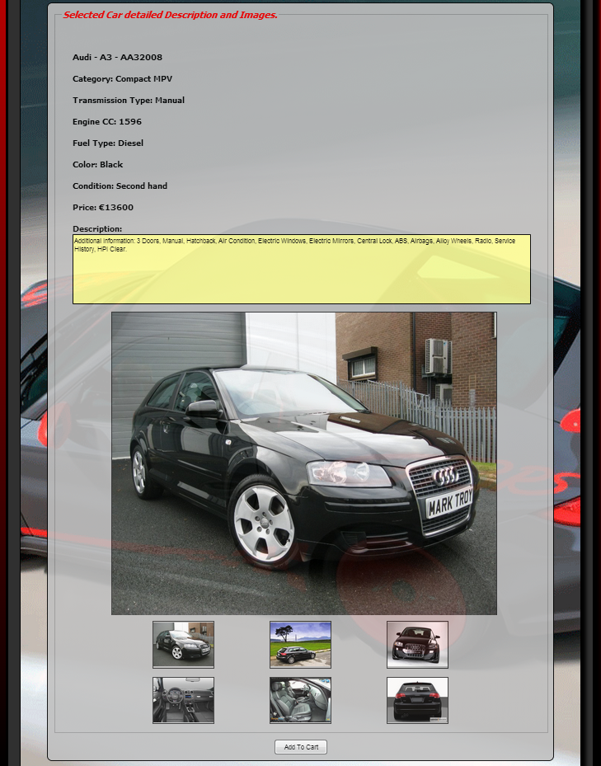

### Fig.96 – Car Description Page

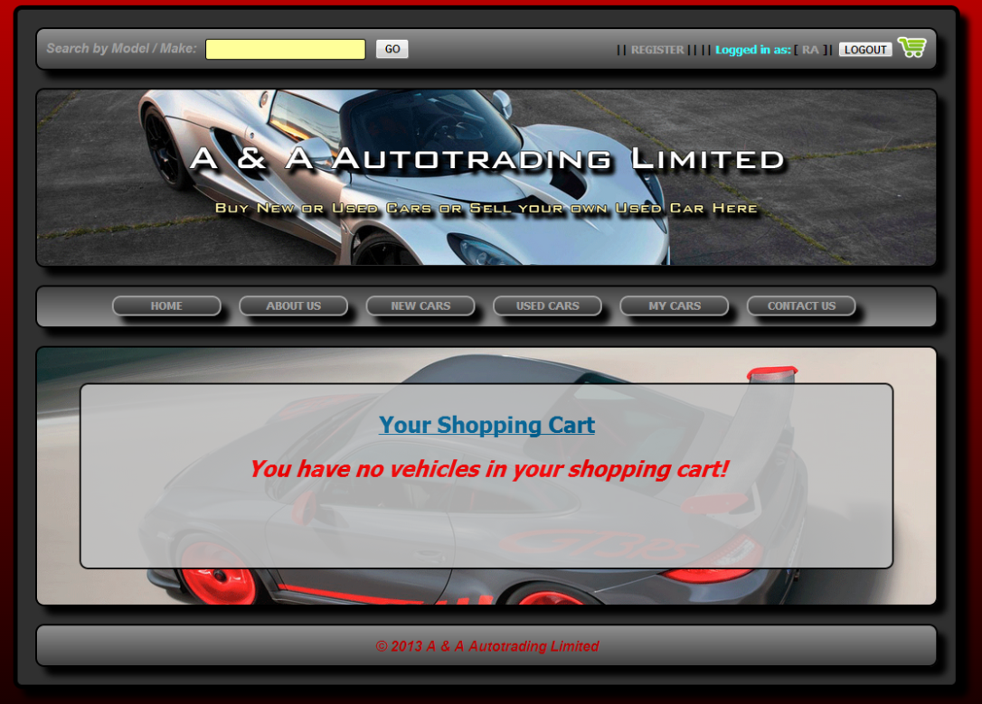

### Fig.97 – Shopping Cart Page (Empty)

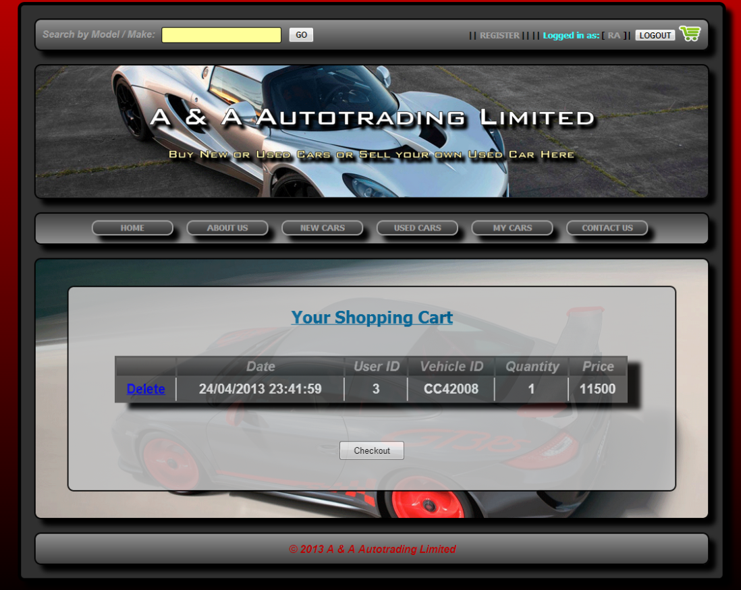

### Fig.98 – Shopping Cart Page (Vehicle added)

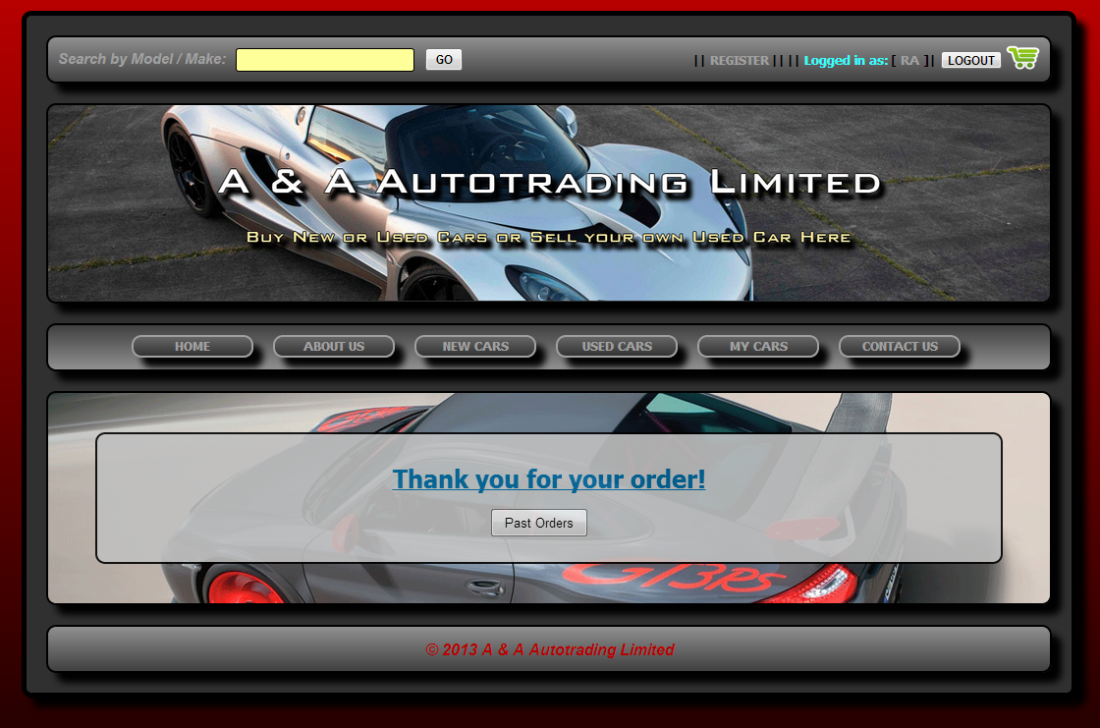

### Fig.99 – Checkout Page (Vehicle Purchase complete)

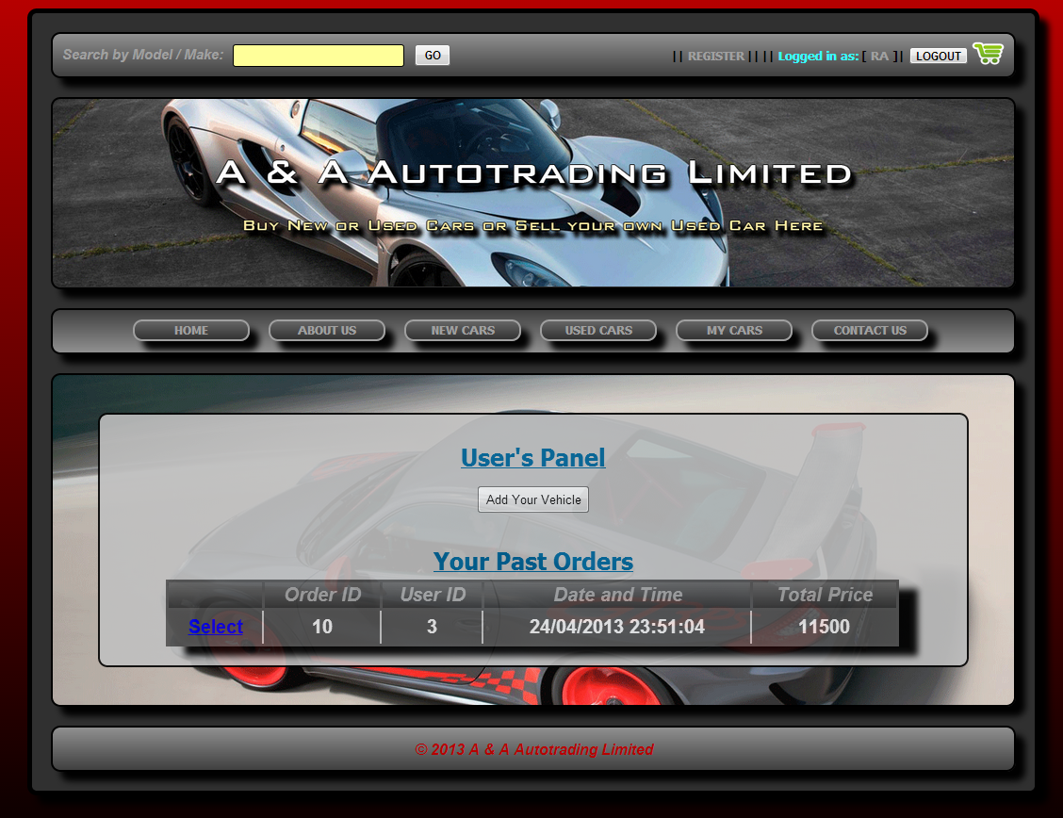

### Fig.100 – User’s Panel Page (Past Orders Purchase)

# Appendix

# Website and Report in Electronic Version (CD-ROM)